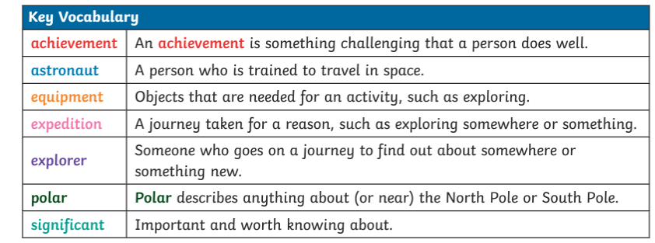
Significant people are people who have made important achievements. They are often remembered and celebrated in different ways.
plaques stamps statues

Big Ideas
What does it take to be a great explorer ?
stamps
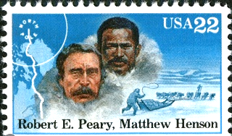
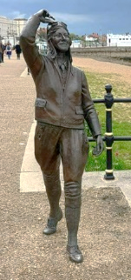
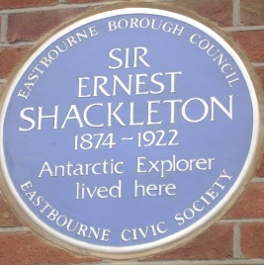

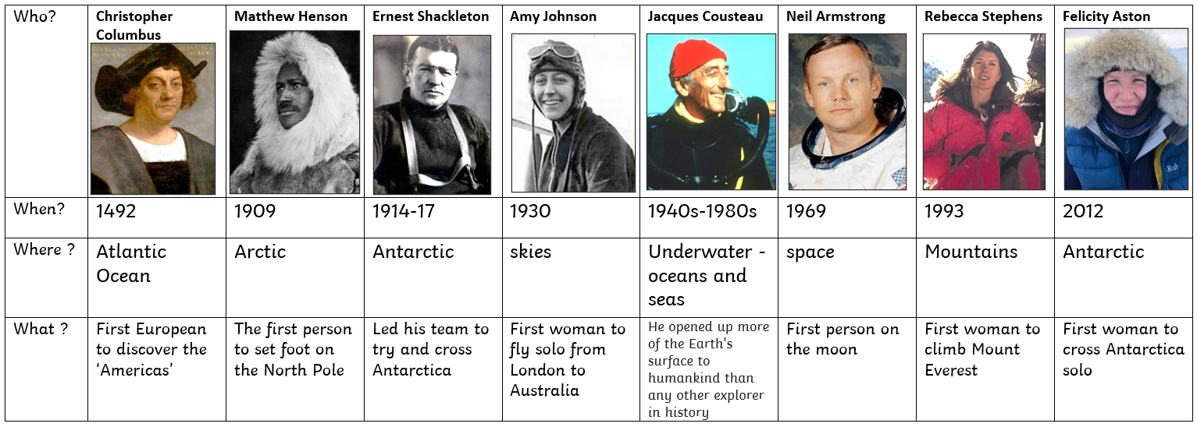

Who? | 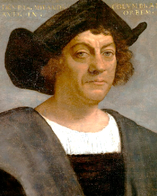  Christopher Columbus | 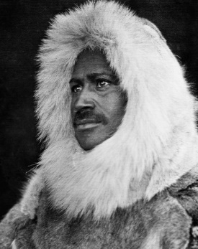  Matthew Henson | 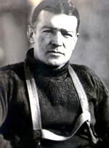  Ernest Shackleton | 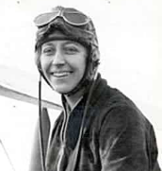  Amy Johnson | 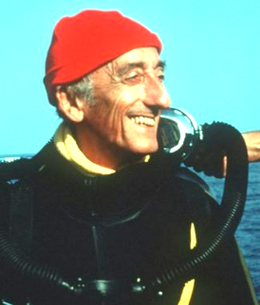  Jacques Cousteau | 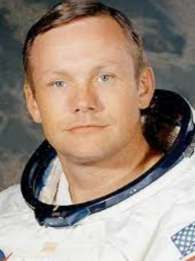  Neil Armstrong | 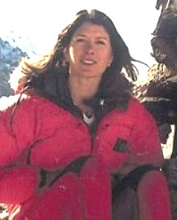  Rebecca Stephens | 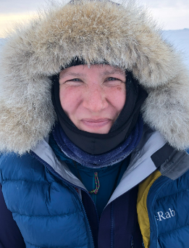  Felicity Aston
When? | 1492 | 1909 | 1914-17 | 1930 | 1940s-1980s | 1969 | 1993 | 2012
Where ? | Atlantic Ocean | Arctic | Antarctic | skies | Underwater -oceans and seas | space | Mountains | Antarctic
What ? | First European to discover the ‘Americas’ | The first person to set foot on the North Pole | Led his team to try and cross Antarctica | First woman to fly solo from London to Australia | He opened up more of the Earth's surface to humankind than any other explorer in history | First person on the moon | First woman to climb Mount Everest | First woman to cross Antarctica solo

