Big Picture
What do I need to survive and succeed?
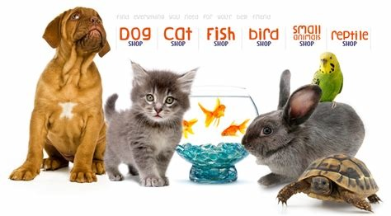
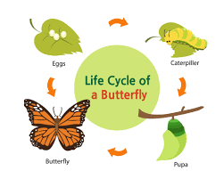

Questions we will explore:

- Can we explain the basic needs of all living things?

- Do you know that animals, including humans, have offspring that grow into adults?

- Can we explore the life cycles of different animals?

- Can we observe and document the life cycle of our class caterpillars?

- Do you know why exercise, food and cleanliness are an important part of keeping healthy?

- Do you know how to take care of your pets?

Questions I would like to ask…

Vocabulary I will use….
- Investigate
- Life cycle
- Survival
- Offspring
- Exercise
- Balanced diet
- Cleanliness

Skills I will use….
- Research
- Observation
- Exploration
- Reflection and evaluation
- Sorting
- Investigating
- Comparison

