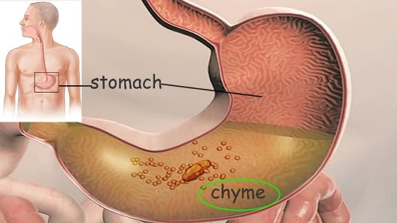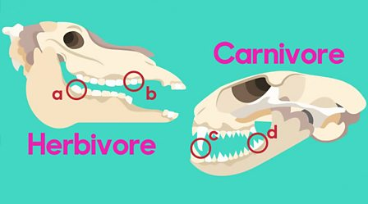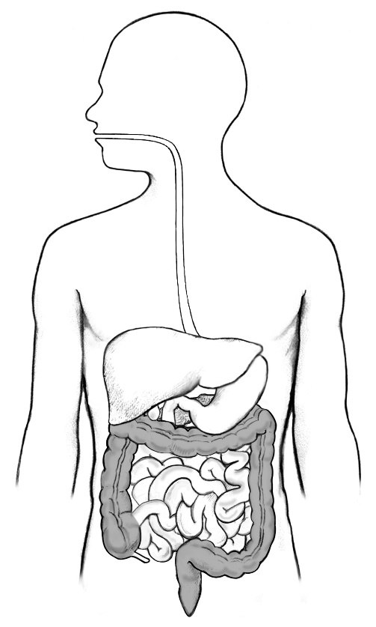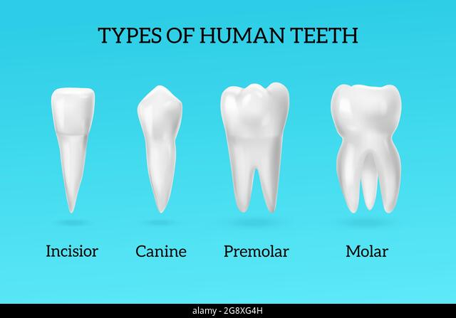

**Question I would like to ask:**

acids

liver

pancreas

small intestine

large intestine

rectum

anus

absorb

**Vocabulary we will use:**

canine

incisor

molar

premolar

saliva

digestion

oesophagus

stomach

**Skills we will use:**

read

record

discuss

listen

observe

predict

present

**What happens to the food we eat ?**

* Why do humans have different types of teeth ?
* **Do different animals have different teeth ?**
* What are the different parts of the human digestive system ?
* **What does each part of the human digestive system do to the food we eat ?**

**BIG PICTURE**