Big Picture

**What do I need to survive and succeed?**

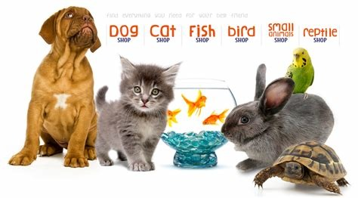

**Questions we will explore:**

* Can we explain the basic needs of all living things?
* Do you know that animals, including humans, have offspring that grow into adults?
* Can we explore the life cycles of different animals?
* Can we observe and document the life cycle of our class caterpillars?
* Do you know why exercise, food and cleanliness are an important part of keeping healthy?
* Do you know how to take care of your pets?

**Questions I would like to ask…**

**Vocabulary I will use….**

* Investigate
* Life cycle
* Survival
* Offspring
* Exercise
* Balanced diet
* Cleanliness

**Skills I will use….**

* Research
* Observation
* Exploration
* Reflection and evaluation
* Sorting
* Investigating
* Comparison