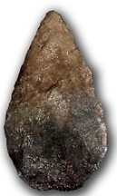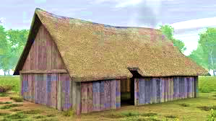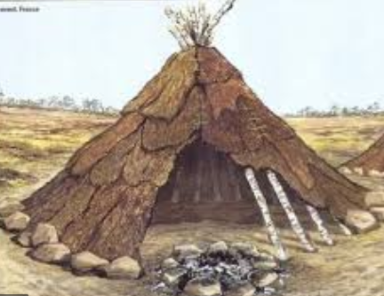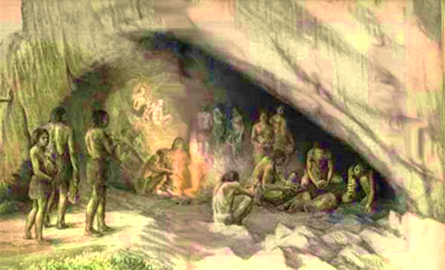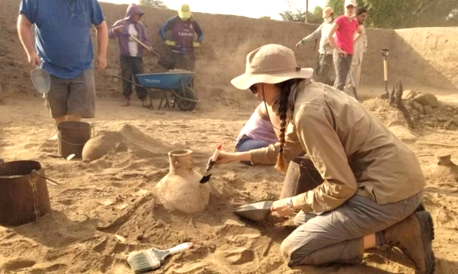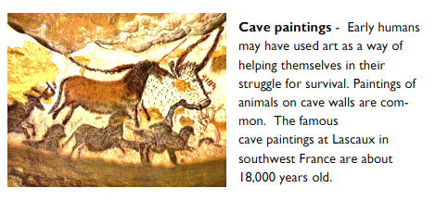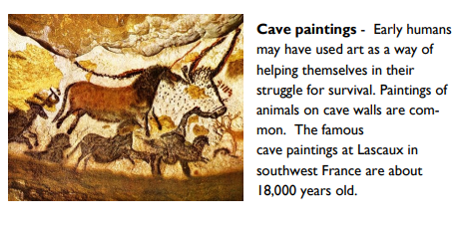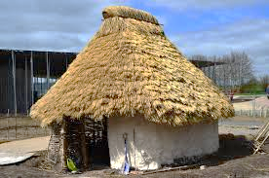

**Mesolithic period** – tool and weapons were developed to become finer and smaller.

The invention of canoes meant that people could now hunt more for fish

**Hunter-gatherer** -a member of a nomadic people who live by hunting and fishing, and harvesting wild food.

**Nomad-** someone who moves from place to place, who has no permanent home

**Wattle and daub-**used to make walls and buildings , made from sticksand a sticky material usually made of some combination of wet soil, clay, sand, animal dung and straw.

**Settlement –** a place where people build homes and live together in a community.

**Flint-** a hard grey rock used to make tools and weapons

**Artefact /artifact-** is something made or given shape by humans

**An archaeologist** is someone who studies human history by digging up human remains and artifacts.

**Palaeolithic period** – people were nomadic hunter-gatherers and found food by roaming from place to place. Tools and weapons were made from stone, wood and bone.

Can you see how shelters changed and developed over the different periods of the Stone Age ?

**Neolithic period** – people now settled into villages and grew their own crops and kept their own animals.