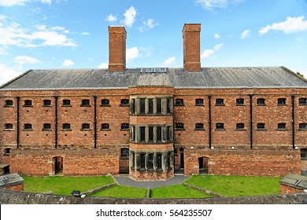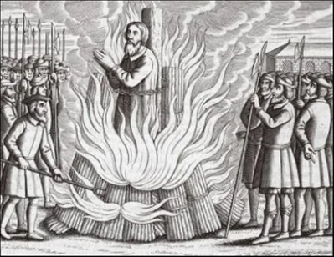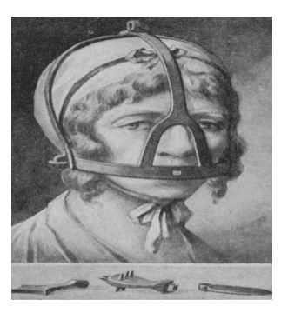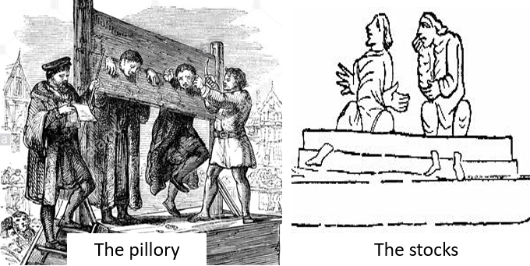

Did the punishment fit the crime ?

**BIG PICTURE**

* How were people in Roman Britain punished?
* How were suspects dealt with in the Anglo-Saxon period ?
* What did the Tudors do to keep law and order ?
* What changes occurred in the Victorian period ?

**Question I would like to ask:**

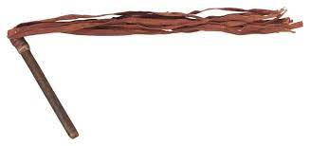

**Vocabulary we will use**

jury

wergild

treason

trial

justice

deterrent

branding

pillory

stocks

**Skills we will use**

reading

discussing

researching

comparing

reflecting

writing

presenting