How can we identify weather patterns?
Big Ideas

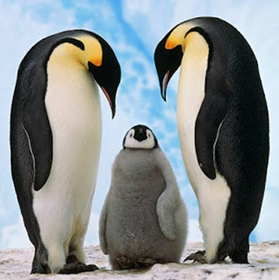

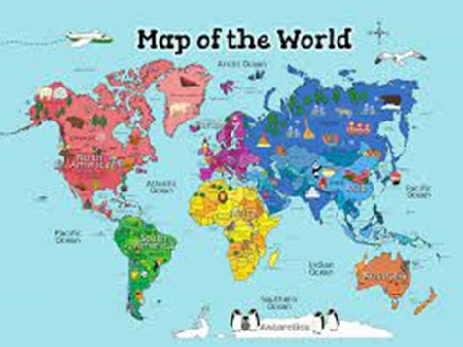
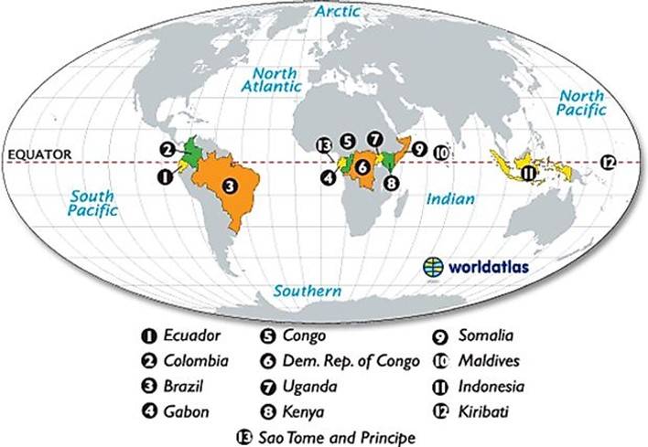
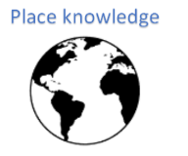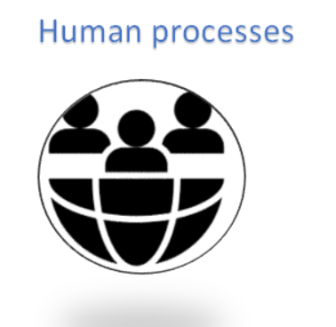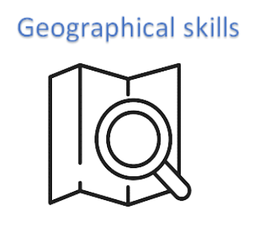
Vocabulary
North Pole | The northern most place on Earth
South Pole | The southern most place on Earth
Equator | An imaginary line around the centre of the Earth
camouflage | When an animal’s markings help it to blend in with its environment
desert | A very dry place that experiences little rain and therefore plants rarely grow
glacier | A slowly moving mass or river of ice

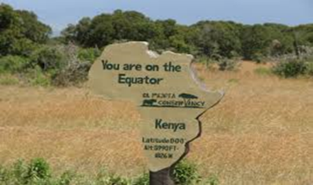
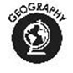
Some countries, like Egypt as hot. Some countries like the Antarctic are cold.
Some animals, like meerkats live in warm countries. Meerkats are often on the lookout because they are tasty treats for birds of prey.
They stay by their burrows, so if a bird of prey comes, they don't have to run so far.

The UK is located in the continent of Europe. It is a small island. A map is flat whereas a globe is sphere-shaped.
The imaginary line that runs around the centre of the Earth is called the Equator.
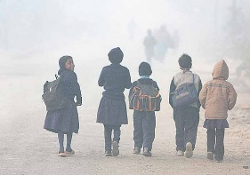
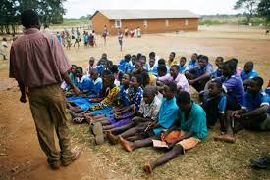

Who? | 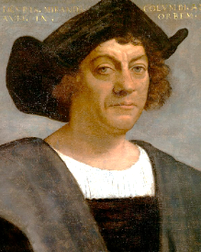  Christopher Columbus | 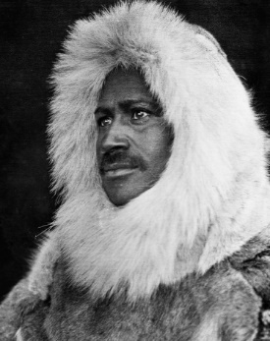  Matthew Henson | 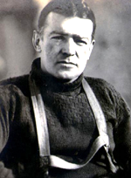  Ernest Shackleton | 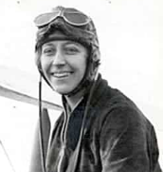  Amy Johnson | 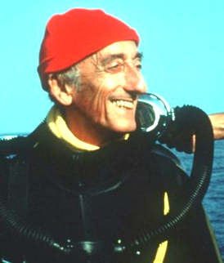  Jacques Cousteau | 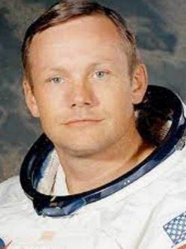  Neil Armstrong | 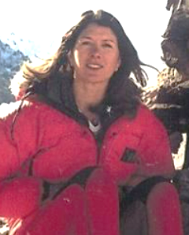  Rebecca Stephens | 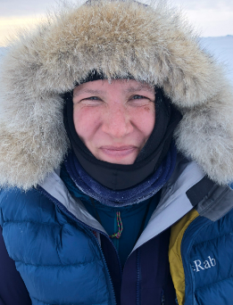  Felicity Aston
When? | 1492 | 1909 | 1914-17 | 1930 | 1940s-1980s | 1969 | 1993 | 2012
Where ? | Atlantic Ocean | Arctic | Antarctic | skies | Underwater -oceans and seas | space | Mountains | Antarctic
What ? | First European to discover the ‘Americas’ | The first person to set foot on the North Pole | Led his team to try and cross Antarctica | First woman to fly solo from London to Australia | He opened up more of the Earth's surface to humankind than any other explorer in history | First person on the moon | First woman to climb Mount Everest | First woman to cross Antarctica solo

