Have we always looked like this?

[](http://www.google.com/url?sa=i&rct=j&q=&esrc=s&source=images&cd=&cad=rja&uact=8&ved=0ahUKEwj015DelrPQAhUnBMAKHSWACKIQjRwIBw&url=http://classroomclipart.com/clipart/Clipart/Faces.htm&bvm=bv.139250283,d.amc&psig=AFQjCNFLQNDnOLpmldN0t2r8j-wgK1Arpw&ust=1479588472092288)[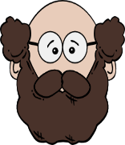](http://www.google.com/url?sa=i&rct=j&q=&esrc=s&source=images&cd=&cad=rja&uact=8&ved=0ahUKEwiR06zxlrPQAhVMJMAKHU3gCA8QjRwIBw&url=http://www.clipartpanda.com/categories/father-face-clipart&bvm=bv.139250283,d.amc&psig=AFQjCNFLQNDnOLpmldN0t2r8j-wgK1Arpw&ust=1479588472092288) [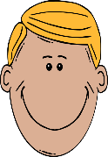](http://www.google.com/url?sa=i&rct=j&q=&esrc=s&source=images&cd=&cad=rja&uact=8&ved=0ahUKEwjFn9Cnl7PQAhWjD8AKHZKQBikQjRwIBw&url=http://cliparts.co/father-face-clipart&psig=AFQjCNFXDemWCwmv3AknQZII4Ae6pFw5mg&ust=1479588578601274)[](http://www.google.com/url?sa=i&rct=j&q=&esrc=s&source=images&cd=&cad=rja&uact=8&ved=0ahUKEwjbqO6Rl7PQAhViKcAKHWWIBg4QjRwIBw&url=http://www.clipartpanda.com/categories/father-face-clipart&psig=AFQjCNFXDemWCwmv3AknQZII4Ae6pFw5mg&ust=1479588578601274) [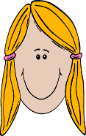](http://www.google.com/url?sa=i&rct=j&q=&esrc=s&source=images&cd=&cad=rja&uact=8&ved=0ahUKEwjax5XPl7PQAhUTOsAKHTjmA1UQjRwIBw&url=/url?sa=i&rct=j&q=&esrc=s&source=images&cd=&cad=rja&uact=8&ved=0ahUKEwjax5XPl7PQAhUTOsAKHTjmA1UQjRwIBw&url=https://www.pinterest.com/sabrinaslawik/comic-jpg-fun/&bvm=bv.139250283,d.amc&psig=AFQjCNEoPCBOIWB1LS2C0sQ3Hyfiga5hRw&ust=1479588700625941&bvm=bv.139250283,d.amc&psig=AFQjCNEoPCBOIWB1LS2C0sQ3Hyfiga5hRw&ust=1479588700625941)**[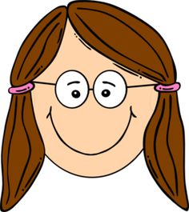](https://uk.pinterest.com/pin/407575834997967108/)**[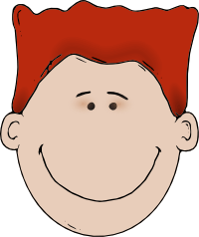](http://www.google.com/url?sa=i&rct=j&q=&esrc=s&source=images&cd=&cad=rja&uact=8&ved=0ahUKEwjSvIezmLPQAhVpBMAKHS_iDdoQjRwIBw&url=http://www.webweaver.nu/clipart/people/kids/&bvm=bv.139250283,d.amc&psig=AFQjCNFig-qqYbAvSqsqzh10s1DGsrVoLg&ust=1479588910425742)

Questions we will explore…

*Could we have evolved from apes, monkeys or other animals?

*What do fossils tell us about “how things have changed”?

*Who was Charles Darwin and why is he still a controversial figure?

*Why do you not look EXACTLY like your mum or dad?

*How is the human skeleton suited to our lifestyle?

Vocabulary: DNA, primates, inheritance,

Evolution, adaptation, environment, variation,

Questions I would like to ask…

Skills I will use:

* Observation
* Reflection and evaluation
* Use of IT.
* Art
* Presentation via powerpoint
* Geography

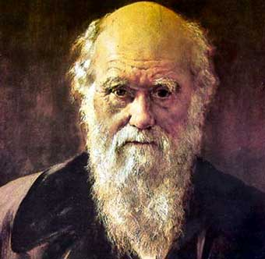

Charles Darwin

Mary Anning

