Big Picture
Why is the Bible such a special book?
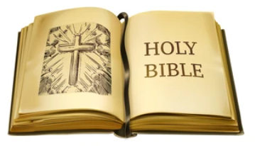
Questions we will explore:

- Who uses the Bible and why it is special to them?
- How did Mary Jones inspired the British Bible Society?
- How and why are the two parts of the Bible are different?
- Which Bible stories from the Old and New Testament do I enjoy?
- Do people of other faiths have a holy book?
Questions I would like to ask…

Vocabulary I will use….
- Bible
- Word of God
- Old Testament
- New Testament
- Faith
- Dead Sea scrolls
- Gospel

Skills I will use….
- Sharing Bible stories
- Observation
- Discussion
- Reflection and evaluation
- Prayer
- Design and creation
- Empathy and comparison

