**Big Picture**

**Are all plants the same ?**

* **How do we group plants ?**
* **What are the criteria for each group ?**
* **Animals have classification keys – can we use them for plants too ?**
* **Can we identify some plants in our school**

**garden ?**

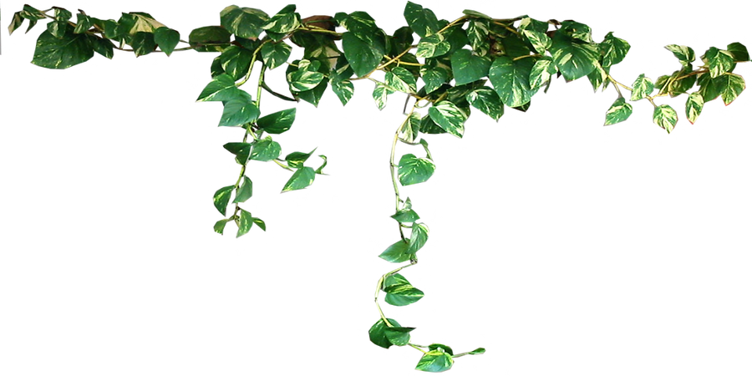

**Vocabulary we will use:**

**plant kingdom**

**adaptations**

**non- vascular**

**vascular**

**gymnosperm**

**flowering plants**

**characteristics**

(non-vasular)

(vasular)

**Are all plants the same ?**

**Question I would like to ask :**

**Skills we will use:**

**read**

**discuss**

**compare**

**investigate**

**record**

**sketch**

**label**