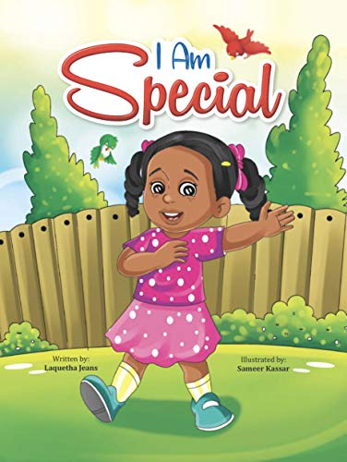**Big Picture-** Religious Education ‘I am Special’.

Skills I will use:

* Observing
* Exploring
* Learning
* Drawing
* Sharing
* Discussing
* Imagining

**Questions We Will Explore**

* What makes me special?
* What does unique mean?

How am I different from everyone else?

**What I want to know?**

**Big Picture-** Understanding the World/PSHE ‘All About Me’

Skills I will use:

* Observing
* Exploring
* Learning
* Drawing
* Sharing
* Discussing
* Imagining

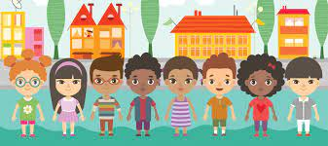

**What I want to know?**

**Questions We Will Explore**

* How do I feel?
* Who lives in my house?
* Do I have any pets?
* What kind of house do I live in?

**Big Picture-** PSHE ‘Who…Me?’

Skills I will use:

* Observing
* Exploring
* Learning
* Drawing
* Sharing
* Discussing
* Imagining

**What I want to know?**

**Questions We Will Explore**

* **How does it feels to belong and how are similar and different?**
* **Can I recognise and manage my feelings?**
* **Can I work together with others and consider other people’s feelings.**
* **Why it is good to be kind and use gentle hands?**
* **I am starting to understand children’s rights and this means we should all be allowed to learn and play.**

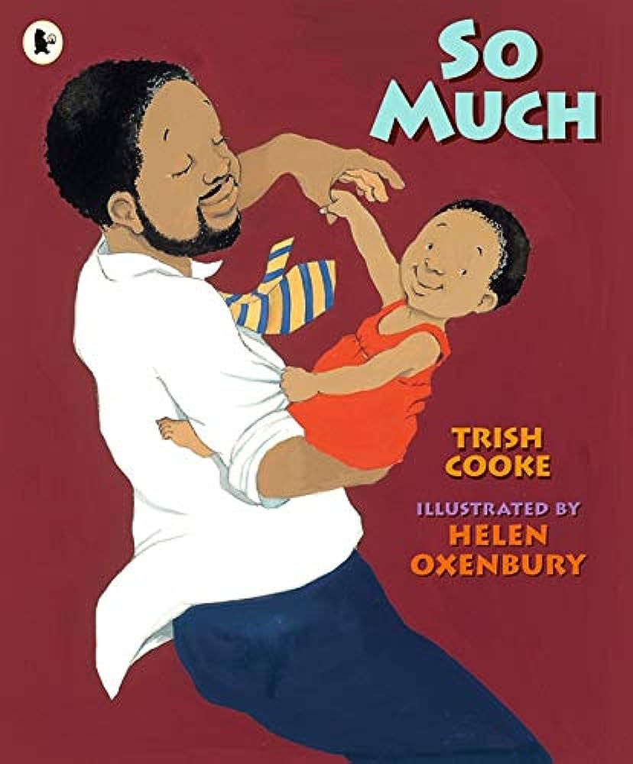**Big Picture-** English ‘So Much!’

Skills I will use:

* Observing
* Exploring
* Learning
* Drawing
* Sharing
* Discussing
* Imagining

**What I want to know?**

**Questions We Will Explore**

* **How does it feels to come from a big family?**
* **Why do they say ‘so much’?**
* **What did you love so much as a baby?**