**Were the Anglo Saxons really smashing?**

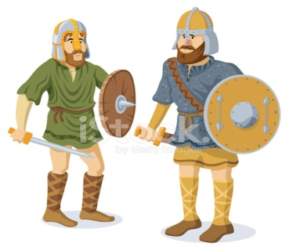

**Questions we will explore:**

|  |  |  |
| --- | --- | --- |
| * Who were the Anglo-Saxons and how did they influence our life today? * How did the Anglo-Saxons bring law and order to Britain? * How did the Anglo-Saxons create different settlements to the ones the Romans had created? * What evidence do we have today that the Anglo-Saxons were ever here in the first place? * Who were the famous Anglo-Saxons and why was Alfred so ‘great’?  |  |  | | --- | --- | |  | Skills we will use: Research including ICT  Debate and discussion  Reflection  DT- use of tools  Reading and evaluating  Atlas work | |

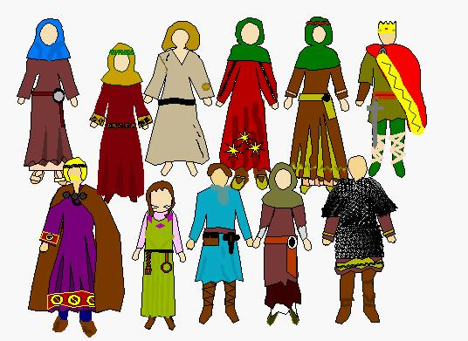 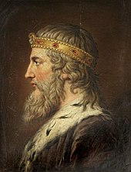

**Vocabulary we will use:**

Timeline, chronological, civilizations, runes, longhouse, Odin, Danelaw, Battle of Hastings, King Alfred the Great

**Questions I would like to ask?**