**BIG PICTURE**

What could be in our fruit salad?

**Questions we will investigate on**

**our learning journey:**

* What is food hygiene and why is it important when preparing food?
* Do I know what ingredients go into a fruit salad?
* Can I prepare and chop fruits safely?
* Can I clean a surface after preparing food?
* Can I suggest ways to improve my fruit salad?`

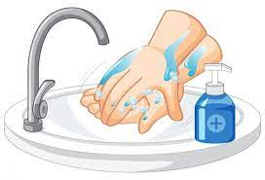

Vocabulary we will use:

hygiene cut

fruit

ingredients

Skills I will use:

Cutting Drawing Observation Listening Reflecting

A question I would like to ask:

___________________________________________