**What did the Romans ever do for us ?**

Big picture

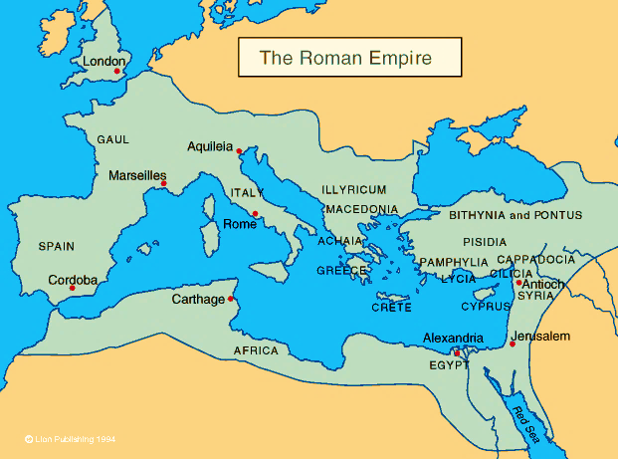

**Questions we will investigate:**

**1. Who were the Romans ?**

**2. Why did they come to Britain ?**

**3. What’s it like to be invaded ?**

***Which countries have been invaded***

***recently ?***

**4. Why did the Romans need to build forts ?**

**5. Who was Boudica and why is she so famous ?**

**6. What did the Romans leave behind ?**

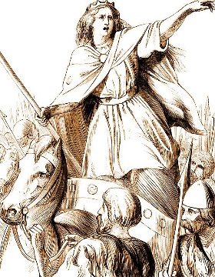

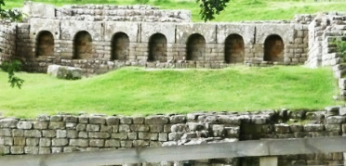

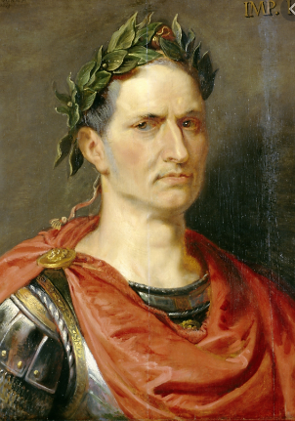

**Disciplinary skills**

historical significance

interpretation

using sources

similarity and difference

continuity and change

cause and consequence

chronology

**Vocabulary we will use:**

**CIVILISATION EMPIRE SOCIETY**

**CONQUEST TRIBES POWER CONFLICT**

invade rule conquer emperor

**Julius Caesar Boudicca**  Iceni tribe

celts fort centurion legion

- chester - cester - caster

rebellion revenge govern

resources artefacts archaeology

primary sources legacy

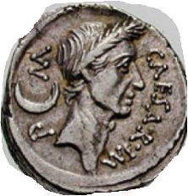

**Question I would like to ask:**

.

Big Ideas

**What did the Romans ever do for us ?**

We invaded Britain for several reasons – you had silver, gold, leather, slaves, land. We were also angry with you because you took sides with the Gauls( French)when they fought against us. We wanted to punish you for that !

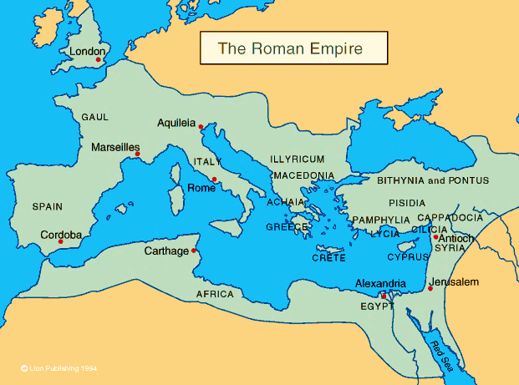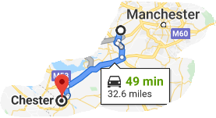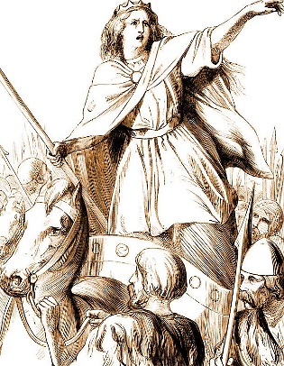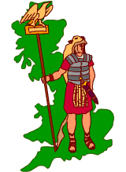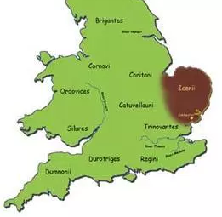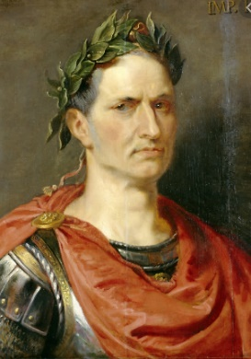

Boudicca was the wife of Prasagustas , leader of the Iceni tribe. They were a tribe of people who lived in this part of Britain in about 47 AD. When he died, he left his lands and power to Boudica ( his wife) However,the Romans decided to take it all from her and take over the tribe. Boudica was furious,. She led her army of over 100,000 men to Colchester ( the main city where the Roman ruled) . She destroyed it ! Then she marched onto London then St Albans – she destroyed them too. But, she and her men were finally defeated in the Midlands. It is believed Boudica drank poison so the Romans could not capture her.

Julius Caesar was a hero of the Roman army and led **the first invasion of the Romans to Britain in 55BC.**

He became emperor in 49 BC. By 46 BC, he was the most powerful man in the world. He was a ***dictator***

Some people were afraid he was too powerful - 2 years later, he was assassinated ( killed)

**What did the Romans give us? ( their legacy)**

Many of our buildings and how they are heated, the way we get rid of our sewage, the roads we use, some of our wild animals, religion, the words and language we speak, how we calculate distances, numbers and why we use money to pay for goods were all introduced by the Romans.

**FORTS were built all over the Roman Empire to protect them from attacks by the people they ruled over.They were made of wood at first , then stone, surrounded by a deep ditch. There are many remains of Roman forts around Britain today.**

The nearest fort to us that can be seen today is in Chester .

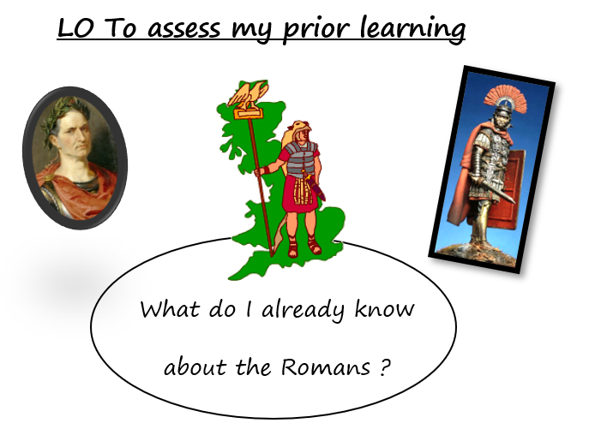

**LO To assess my prior learning**

****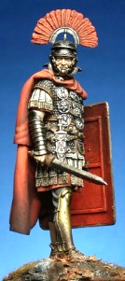

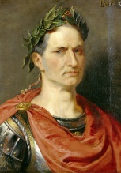

What do I already know

about the Romans ?

Chronology

Cause and consequence

Sources

interpretation

Continuity and change

Historical

significance

Cause and consequence

Similarity and difference

Continuity and change

Sources

Historical

significance

Sources

interpretaion

chronology

Cause and consequence

Continuity and change