|  |  |
| --- | --- |
| **Key Words** | |
| Special | To be unique or important |
| Disciple | One of Jesus’ trusted friends |
| Friendship | To be kind and close to someone else |
| Jesus | Christ’s child |
| Miracle | When someone amazing happens |

**What made Jesus special?**

**BIG IDEAS**

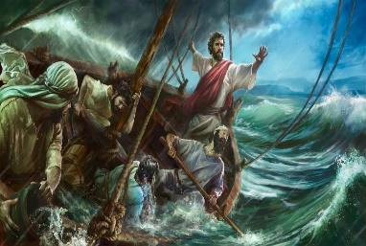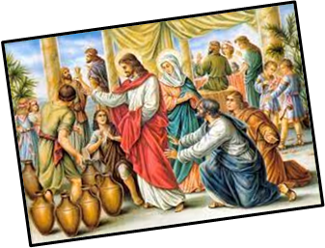

There are lots of stories about Jesus that tell us how special he was; The Calling of the Disciples, The Feeding of the 5000 and Turning Water into Wine. These stories teach us about Jesus.

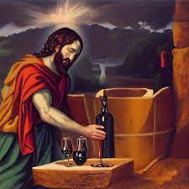 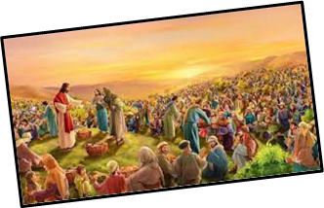

Jesus has special friends that wanted to help him to spread his message to everyone.

His friends were called his disciples.

Jesus has special friends that wanted to help him to spread his message to everyone.

His friends were called his disciples.

Jesus has special friends that wanted to help him to spread his message to everyone.

His friends were called his disciples.

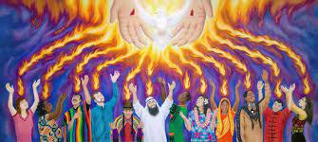 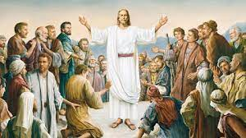 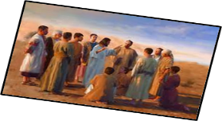

The wind and the waves obey him – Believing in Jesus means that you can get through anything. We are his people too and we should obey his teaching.

