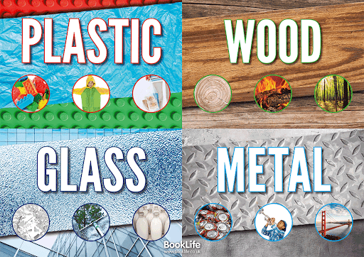

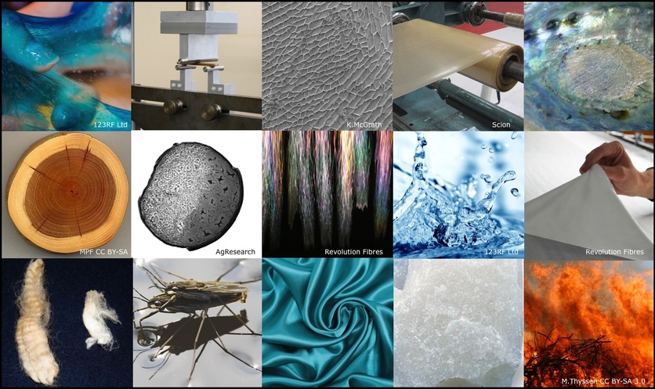

Big Picture

**How do we make the most of the materials around us?**

**Question I would like to ask…**

**Skills we will use:**

**Research, grouping and classifying, Talk partners observing, drawing, discussing, writing.**

**Questions we will explore…**

* **Why are some materials more suitable than others for making our toys?**
* **Why would glass, wood, plastic, brick or metal be used for particular jobs?**
* **Why can some materials be squashed, twisted or bent according to need?**
* **Why certain materials are suitable for many different uses?**
* **Who are the people that have developed useful new materials?**

**Vocabulary we will use…**

Materials, squashed, twisting, glass, wood, plastic, build, brick, metal , inventor.

