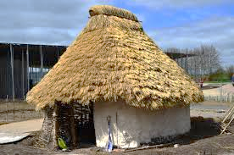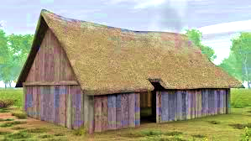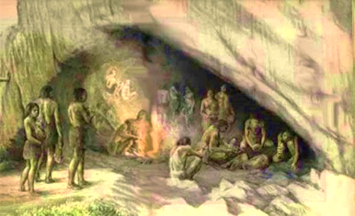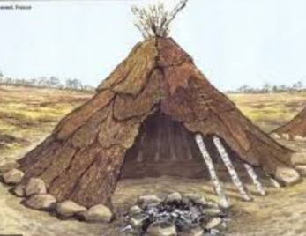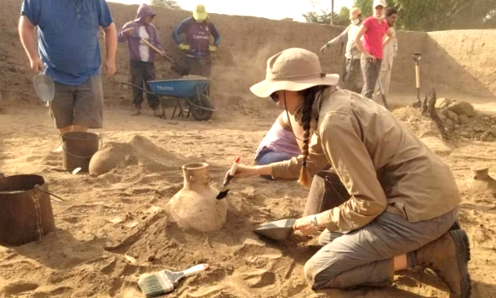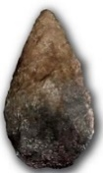

Romans invade Britain

**How did Britain change from the beginning of the Stone Age to the end of the Iron Age ?**

**Palaeolithic period** – people were nomadic hunter-gatherers and found food by roaming from place to place. Tools and weapons were made from stone, wood and bone.

**Mesolithic period** – tool and weapons were developed to become finer and smaller.

The invention of canoes meant that people could now hunt more for fish

**Neolithic period** – people now settled into villages and grew their own crops and kept their own animals.

**Hunter-gatherer** -a member of a nomadic people who live by hunting ,fishing and harvesting wild food.

**Nomad-** someone who moves from place to place, who has no permanent home

**Wattle and daub-**used to make walls and buildings , made from sticksand a sticky material usually made of some combination of wet soil, clay, sand, animal dung and straw.

**Settlement –** a place where people build homes and live together in a community.

**Skara Brae –** an archaeological site in Orkney Islands, Scotland

**Flint-** a hard grey rock used to make tools and weapons

**Artefact -** is something made or given shape by humans

**Iron Age forts** -A settlement built on a hill so that it was easier to defend against enemies

**Prior knowledge-** we can organise events into the order they happened on a timeline. This is called **chronological** order.

**Y4** The Romans and The Ancient Greeks left behind artefacts which historians can use to find out about people of the past.

The Romans invaded Britain in 43 AD , after the Stone Age period.

**Y3** Our school was built in the Victorian era. This is after the Stone Age.

**An archaeologist** is someone who studies human history by digging up human remains and artefacts.

Iron Age hill fort