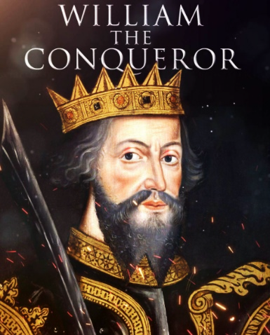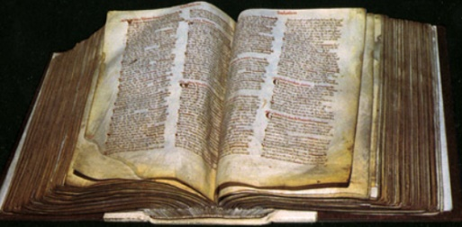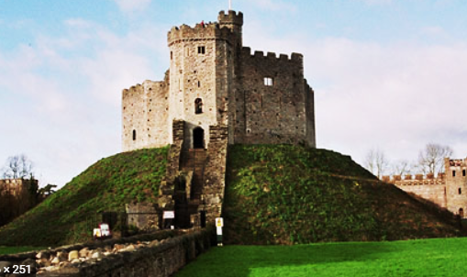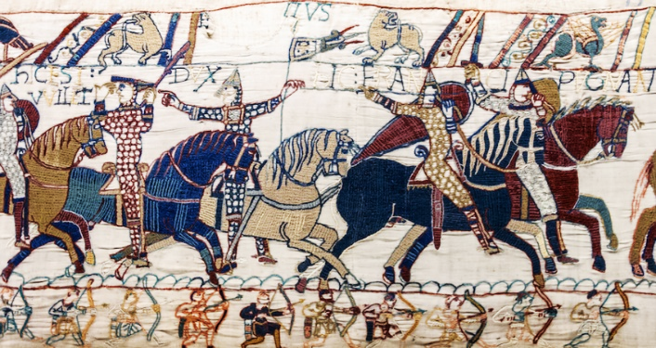

Why did the Normans build so many castles ?

Questions we will investigate on our learning journey:

* Who was William the Conqueror and why is 1066 a famous date in British history ?
* Why did the Normans build castles and what were they like ?
* What is the Doomsday Book and do we have something similar today ?
* What changed in Britain as a result of the Norman conquest ?

Question I would like to ask :

Vocabulary we will use on our learning journey:

monarchy

heir

conquest

defence

elite

feudal

fief

vassal

knight

baron

peasant

motte

bailey

keep

**BIG PICTURE**