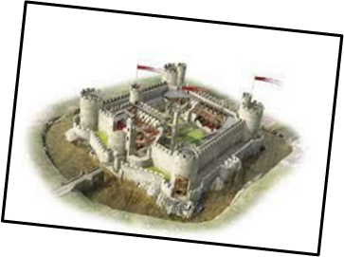
Big Ideas
Why do we have castles?

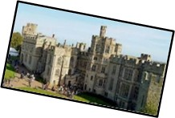
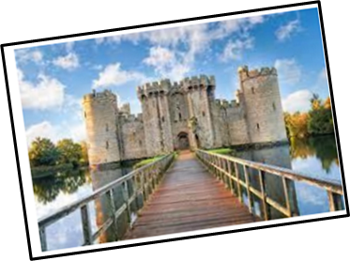
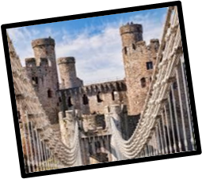
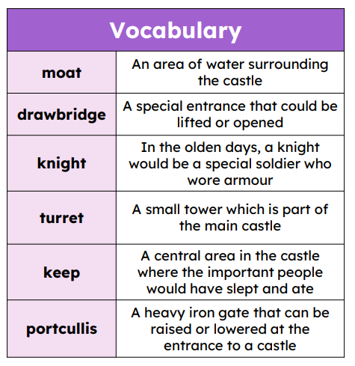
In a typical castle you would find lots of servants. Some were workers within the castle and slept there. These were normally important people, such as the constable who looked after the castle when the lord was away.
Others like the farmers lived in the cottages around the castle. They were called peasants and they grew all the food for those living in the castle.

Castles are a type of home built to protect the people inside. People who lived in the castle included lords, who were in charge, soldiers to defend it from enemy invaders, and even cooks and cleaners to keep everyone fed and the castle tidy.

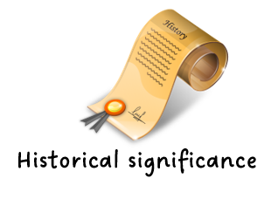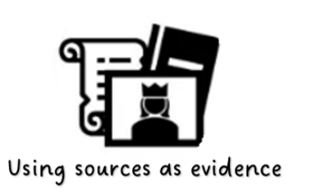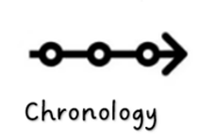
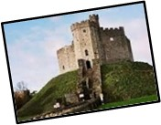
Different parts of castles have special names like drawbridge or moat.
Some of the more familiar
fairy tales are Rapunzel and
Cinderella

