Big Picture

**Why would a dinosaur NOT make a good pet?**

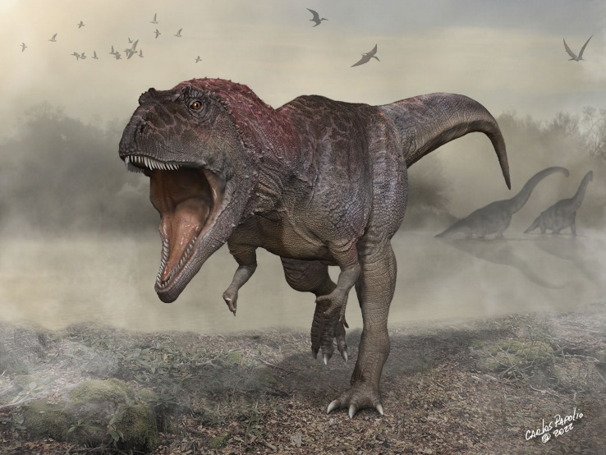

**Questions we will explore:**

* Can you sort animals into their groups and describe their key features?
* Can you create a timeline for the age of the dinosaurs?
* Can you explain the differences between a carnivore, herbivore and omnivore?
* What is a fossil and what information can we gather from them?
* Who is Mary Anning and what is she famous for?

**Questions I would like to ask…**

**Vocabulary I will use….**

* Jurassic, Triassic and Cretaceous periods
* Herbivore, Carnivore and omnivore.
* Fossil
* Features
* Investigate

**Skills I will use….**

* Research
* Observation
* Explore artifacts
* Reflection and evaluation
* Sorting
* Investigating
* Empathy and comparison