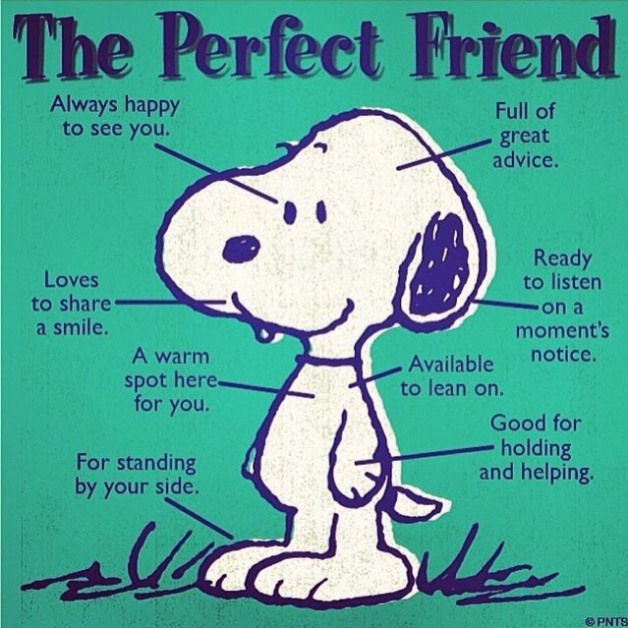**Big Picture-** Religious Education ‘Friendship’

Skills I will use:

* Observing
* Exploring
* Learning
* Drawing
* Sharing
* Discussing
* Imagining

**Questions We Will Explore**

* What is a friend?
* What makes a good friend?
* How do you make friends?
* Who are your friends and why?
* How do you know you are a good friend?
* Who were Jesus’ friends?

**What I want to know?**

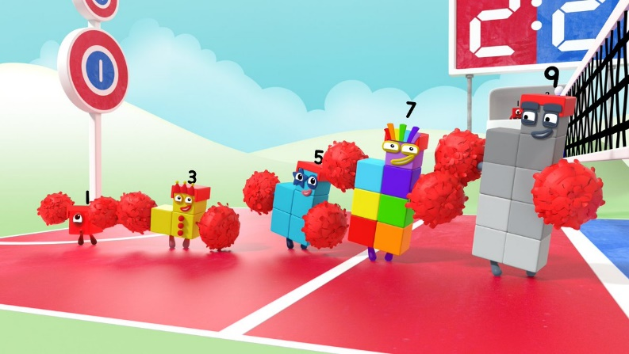**Big Picture** Maths

Skills I will use:

* Observing
* Exploring
* Learning
* Drawing
* Discussing

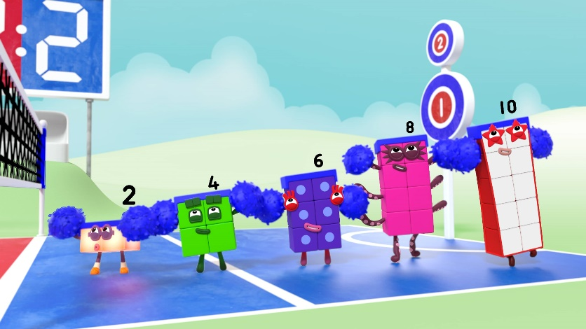

**What I want to know?**

**Questions We Will Explore**

* What is subitising?
* What is an odd top?
* What is an even top?
* What are teen numbers?
* What is counting in twos?

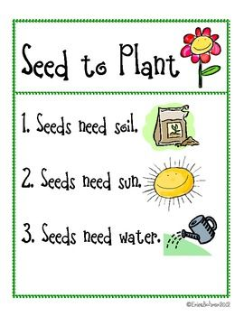

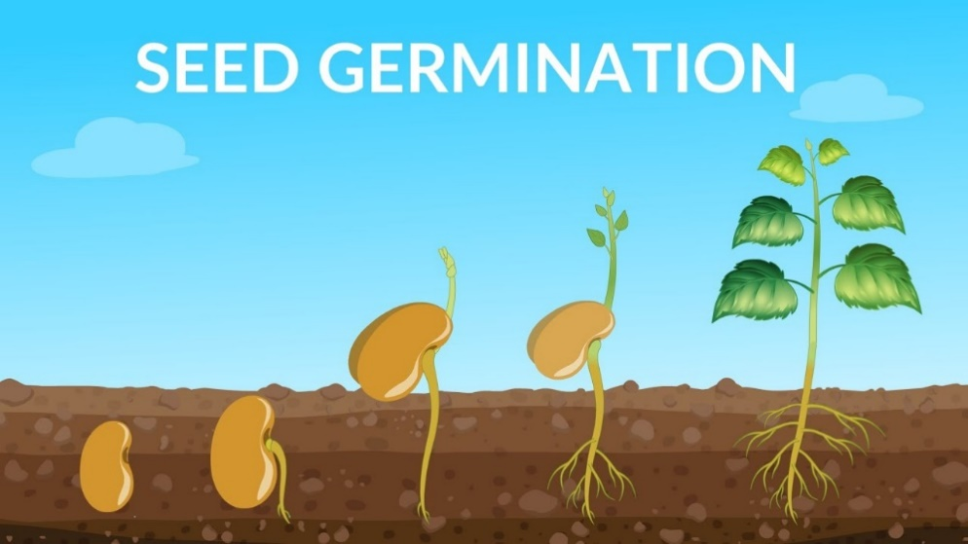**Big Picture -** Understanding the World/English

Skills I will use:

* Observing
* Exploring
* Learning
* Drawing
* Sharing
* Discussing
* Imagining

**What I want to know?**

**Questions We Will Explore**

* How do seeds grow?
* What helps a seed to grow?
* What can we do to support the seed?
* Why do we need plants?
* How do plants help the Earth?

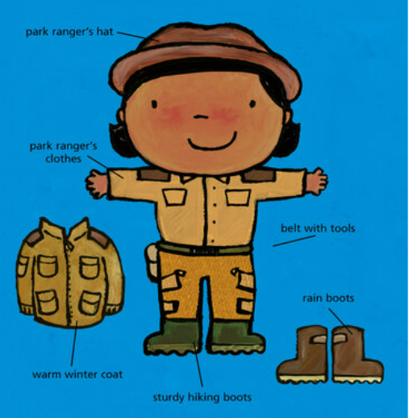**Big Picture-** Topic ‘Park Rangers’

Skills I will use:

* Observing
* Exploring
* Learning
* Drawing
* Sharing
* Discussing
* Imagining

**What I want to know?**

**Questions We Will Explore**

* What does a park ranger/park keeper do?
* What does a park ranger/park keeper need?
* What jobs does the park ranger/park keeper need to do to keep the park safe?