**Would I like to have been an Ancient Egyptian ?**

**Vocabulary we will use**

civilisation

Ancient Egypt

Egyptians

egyptology

Pharaoh

mummification

**Questions we will explore**

* **When did the Ancient Egyptian civilization begin ?**
* **How do we know so much about the people of Ancient Egypt ?**
* **Why was the River Nile so important to the Ancient Egyptians ?**
* **Why did they mummify bodies and build pyramids ?**
* **Who was the most important person in Ancient Egyptian society ?**

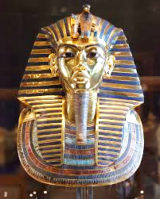

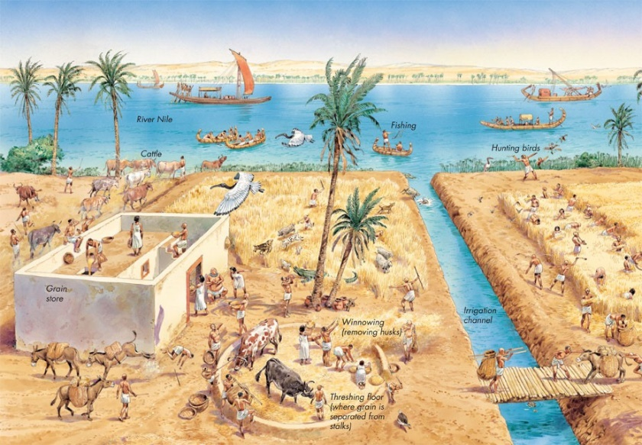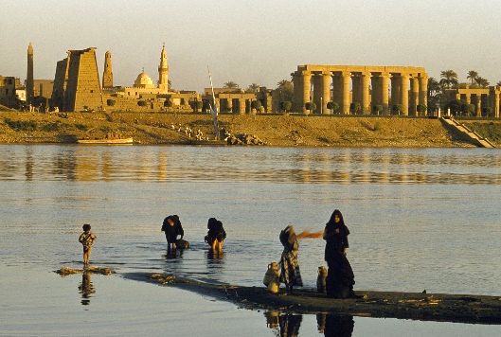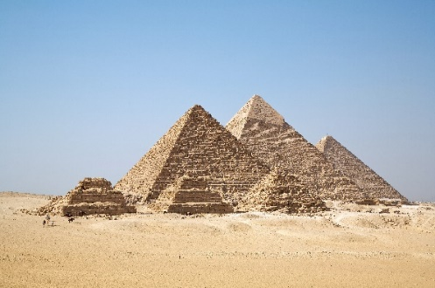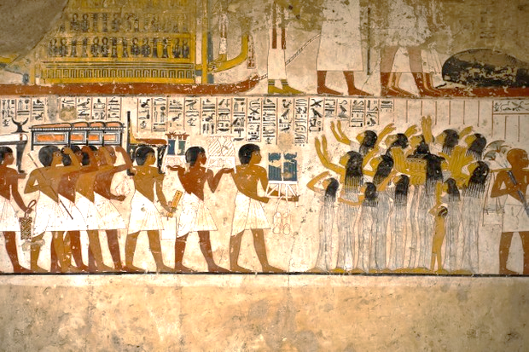

Book of the Dead

Anubis

hieroglyphics

River Nile

irrigation

canopic jars

Osiris

Isis

embalm

**Question I would like to ask**

**Skills I will use**

organise (chronologically)

describe

compare

investigate

explore

identify

read

present