Why school has changed
Social Story

People are talking about Coronavirus as it is a new illness. It is similar to a flu bug.

Children and adults are very good at getting better when they get the flu.

School will feel different for a while and I might feel worried. All the adults in school are there to look after me and help me if I feel worried.

To help keep everyone healthy, some adults and children will not be coming into school. I will still come into school.

To stay safe and healthy I cannot be close to other people.
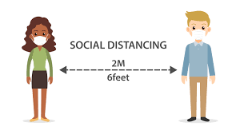

My classroom and some parts of school will look different.

Insert picture of classroom/ areas of school e.g. dinner hall

When everyone is healthy again, all the other adults and children will return to school and we will be able to continue with our learning together.

