Key Words
Safe | When we feel safe and secure
Special | When we feel we are important
Calm | To not feel scared or worried
Belonging | To be part of something
Rights | Something that we are entitled to
Responsibilities | Something that is expected from us.
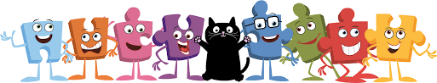
BIG IDEAS
Being Me in My World

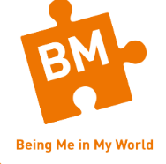
I know when I feel sage and special!

I understand the rights and responsibilities of being in my class!

I can work well with others in my class!



I can follow the LEARNING CHARTER!
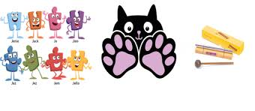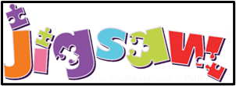
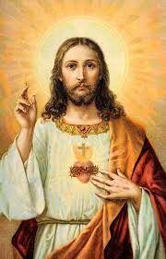
I know my views are valued and that I matter!

