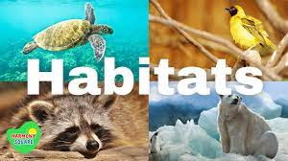

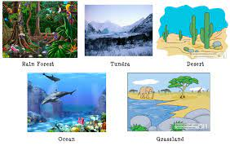

Big Picture

**Why do animals choose the habitats they have?**

**:Skills we will use: to know that we can ask questions about the world and that when we observe the world to answer these questions, this is science.**

**Talk partners, research, grouping and classifying, observing, drawing, discussing, writing.**

**Questions we will explore…**

* Which animals live **underground**, **on the ground** or **in trees**?
* Which animals live in woodlands and forests in the UK and abroad?
* Which animals do we normally find in our seas, rivers, lakes and ponds and why are they there?
* Which animals start their life as an egg?
* Which food sources are linked to which animals?

**Vocabulary we will use…**

**habitat Rainforest desert species pond indigenous**

**Question I would like to ask…**

