**Ascension and Pentecost – Why are these special?**

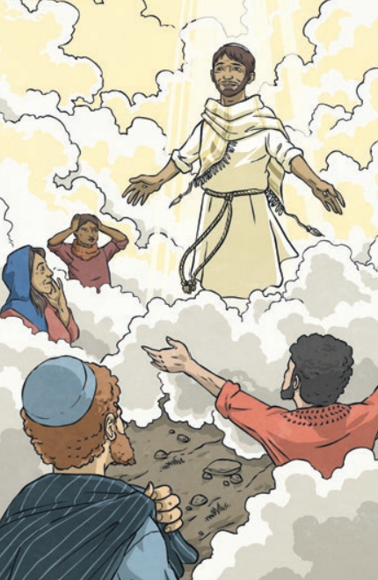

**Questions I would like to explore?**

* Why are these two events so important?
* What is the impact of these events then and now?
* In what ways do these events and beliefs make Christianity distinctive?
* What do Christians believe about the nature and character of the Holy Spirit?

*Values:*

* Faith
* Trust

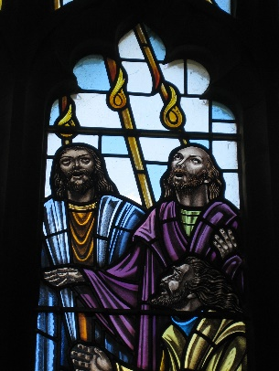

*Vocabulary we will use:*

Ascension, Pentecost, Trinity, Holy Spirit and inspiration

Skills I will use:

* Apply
* Interpret
* Express

Questions I would like to ask...