 | Big Ideas- Exploring the lives of significant women in the Old Testament
Key vocabulary | Explanation/ definition | Key Knowledge
Ruth | Was a woman from the Old Testament who was a loyal friend to her mother-in-law Naomi by not leaving her alone and continuing to support her rather than going back to her own family after the death of her son, Ruth’s husband. | - There are significant women in the Bible who made incredible choices that have an impact on God’s Big story.  - Worship can be expressed in a variety of ways including prayer, dance, compassion and self-sacrifice.  - Sometimes people of faith face great challenges and remain true to their faith.  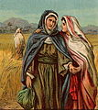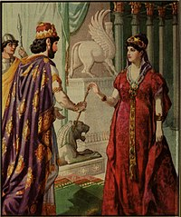  Ruth and Naomi Esther Hamantaschen a traditional food eaten  at The Jewish festival of Purim  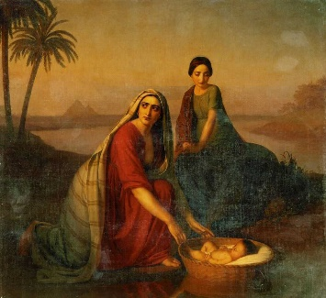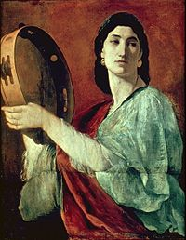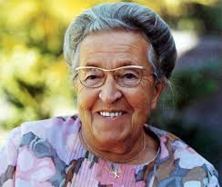  Jochebed Miriam Corrie Ten Boom
Esther | Stands as one of the great figures of courage and faith in the Old Testament. Her people, the Israelites, were living in Babylon and had people plotting against the Jews hoping to kill them. Queen Esther approached the king and was able to save her people.
Jochebed | The daughter of Levi, the wife of Amram and the mother of Aaron, Miriam and Moses.
Deborah | One of the most influential women of the Bible. As a prophet, Judge Deborah was said to hear God’s voice and share God’s word with others. As a priestess, she did not offer sacrifices, as the men did, but she did lead worship services and preach.
Miriam | The daughter of Amram and Jochebed and sister of Aaron and Moses. She was a prophetess and first appears in the Book of Exodus. The Torah refers to her as ‘Miriam the Prophetess’ and as Moses taught the Torah to the men, Miriam taught the Torah to the women.
Key skills
By the end of this unit, pupils are expected to be able to:
- Make links between their own values and the values of others (i.e. the women in the Bible).
- Ask important and relevant questions about the lives of the women in the Bible.
- Ask and suggest answers to questions of identity, meaning, purpose, truth, values and commitments.
- Reflect on the lives of the women in the Bible and describe the features that inspire them.

