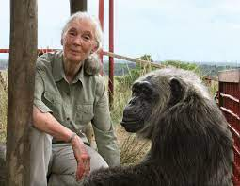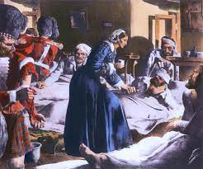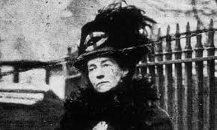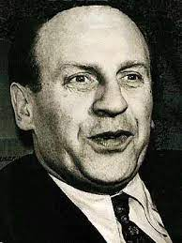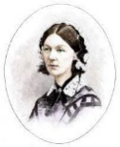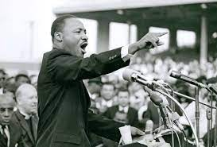

Question I would like to ask:

Skills we will use:

reading

sequencing

reasoning

research

explaining

Vocabulary we will use :

significant

chronology

timeline

inspire

campaign

support

**Questions we will investigate on our learning journey:**

* Who was Florence Nightingale and how did she make hospitals cleaner and nicer?
* Who was Emily Davison and what did she do to support women’s rights?
* Who was Oskar Schindler and how did he help Jewish people in WW2?
* Who was Martin Luther King and how did he campaign for freedom and equality?
* Who is Jane Goodall and what has she done to inspire people to look after animals and our planet?
* Can I place these people in chronological order on a timeline?
* Can I suggest how I may make the world a better place when I am older?

**How have people helped to make the world a better place?**

**BIG PICTURE**