
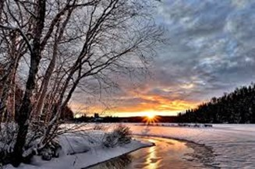
Big Picture
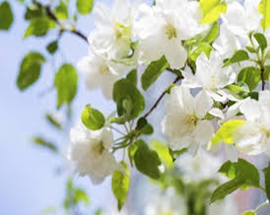

Autumn 1
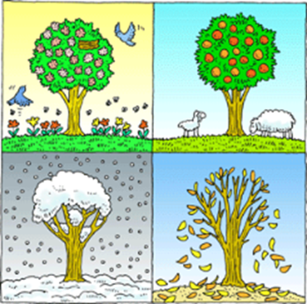
What is seasonal change?
Vocabulary we will use…
autumn, winter, summer, spring, temperature, weather symbols

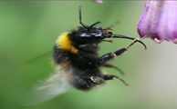
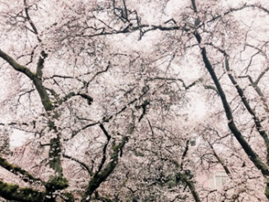
What will we explore in this unit?
- Why do we have seasons and what are the months associated with each?
- Why do most people love the spring?
- What do we know about summer?
- Why are there so many leaves on the floor in autumn?
Question I would like to ask:
________________________________________________

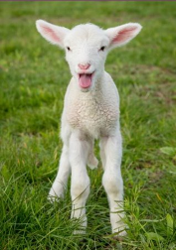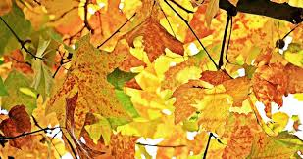
Skills we will use;
Talk partners, research, grouping and classifying, observing, drawing, discussing, writing.

