**BIG PICTURE**

**What made Jesus special?**

**Questions we will investigate on**

**our learning journey:**

* What does special mean?
* Jesus was special. Why?
* What made Jesus special?
* Who were the special friends of Jesus and how did they try to follow his teachings?
* Why did the wind and waves obey Jesus?

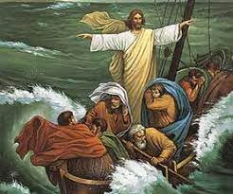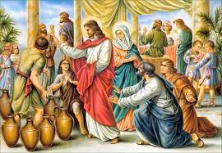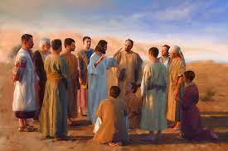

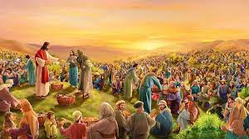

Vocabulary we will use on our

learning journey:

Jesus Son of God

Friendship Miracle

Disciple

Question I would like to ask:

