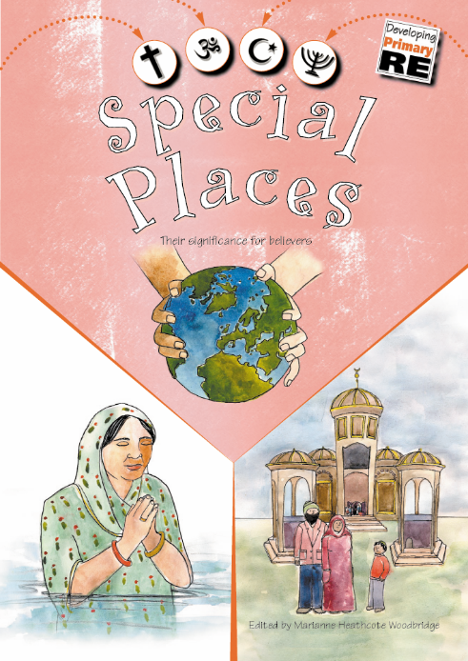**Big Picture-** Religious Education ‘Special Places’

Skills I will use:

* Observing
* Exploring
* Learning
* Drawing
* Sharing
* Discussing
* Imagining

**Questions We Will Explore**

* What is a special place?
* What makes is special?
* How do you feel when you are in the special place?

**What I want to know?**

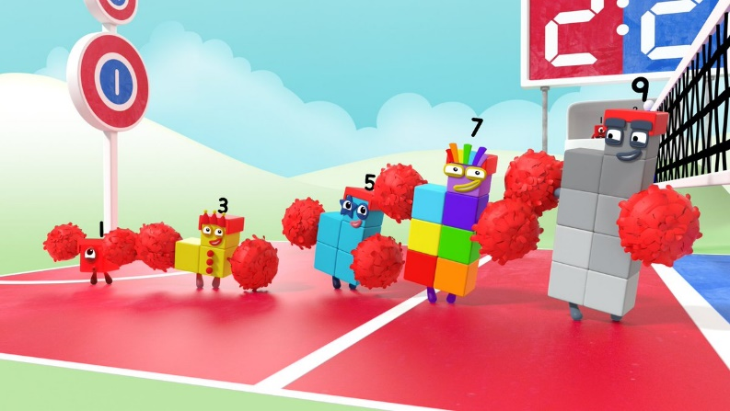**Big Picture** Maths

Skills I will use:

* Observing
* Exploring
* Learning
* Drawing
* Discussing

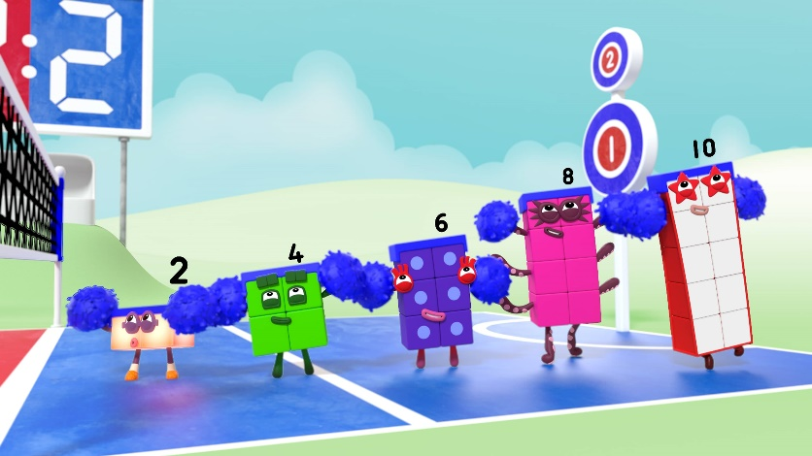

**What I want to know?**

**Questions We Will Explore**

* What is subitising?
* How do we double?
* How do we share?
* What is equal?
* How can we share between more than two?

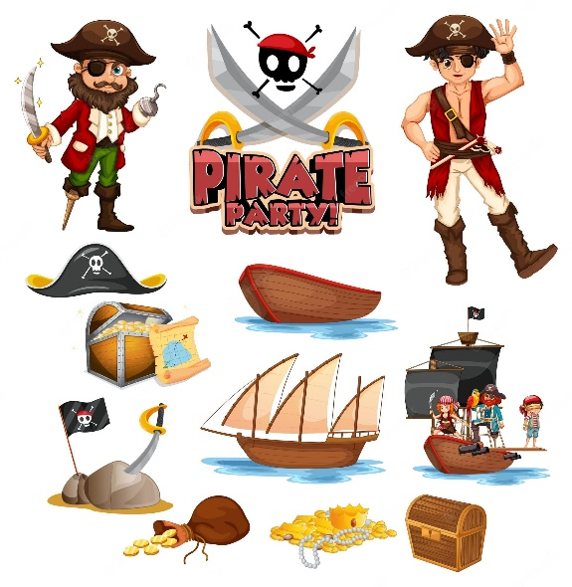**Big Picture-** Topic/English ‘Pirates’



Skills I will use:

* Observing
* Exploring
* Learning
* Drawing
* Sharing
* Discussing
* Imagining

**What I want to know?**

**Questions We Will Explore**

* What does a pirate do?
* How do you become a pirate?
* What do you need to be a pirate?
* What is a pirate ship?

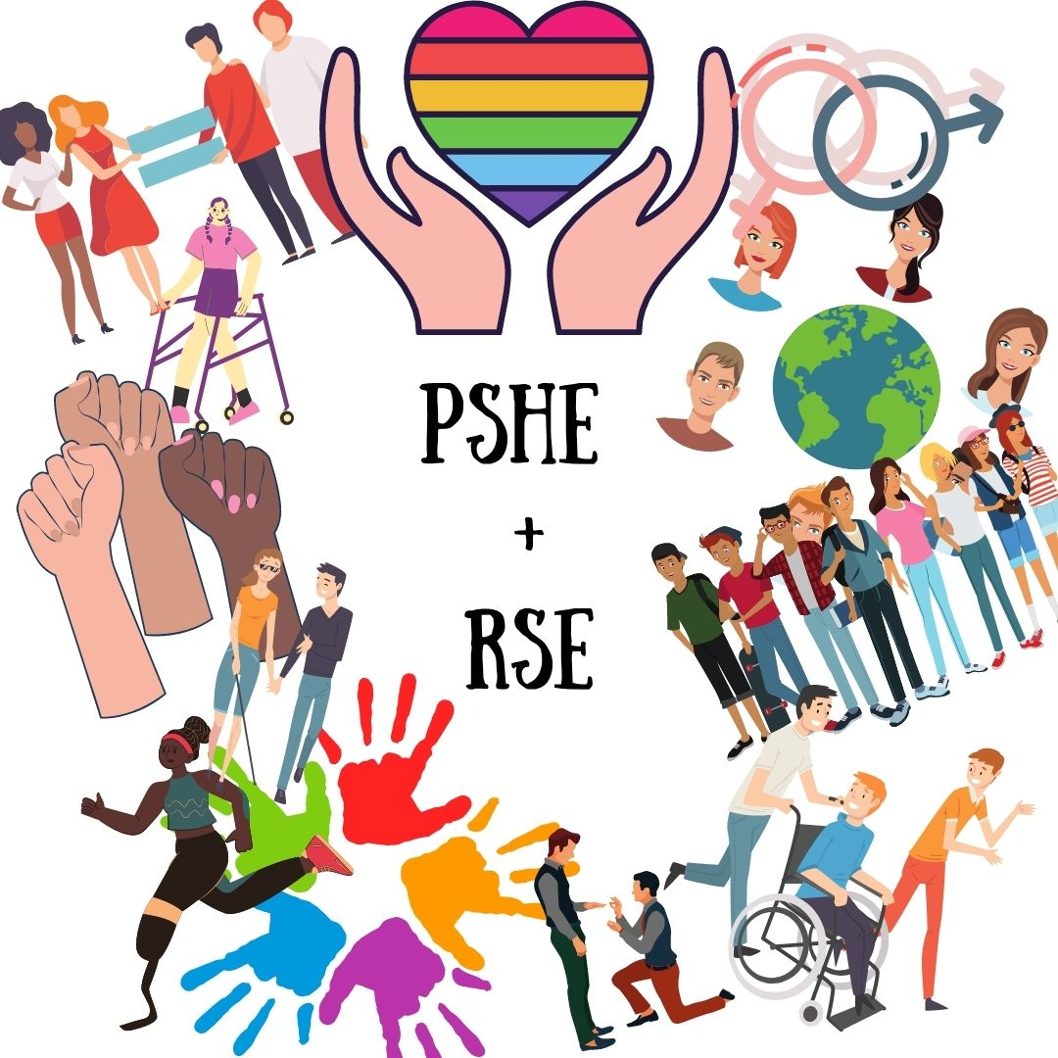**Big Picture-** PSHE ‘Being Me, Who in My World?’

Skills I will use:

* Observing
* Exploring
* Learning
* Drawing
* Sharing
* Discussing
* Imagining

**What I want to know?**

**Questions We Will Explore**

* **How does it feels to belong and how are similar and different?**
* **Can I recognise and manage my feelings?**
* **Can I work together with others and consider other people’s feelings.**
* **Why it is good to be kind and use gentle hands?**
* **I am starting to understand children’s rights and this means we should all be allowed to learn and play.**