BIG PICTURE
Why do people in the nativity story travel to Bethlehem?

Questions we will investigate on our learning journey:
- Why did Mary and Joseph make the journey to Bethlehem?
- Why was Jesus born in Bethlehem?
- In what ways would their journey be different from a journey you might take?
- Many other people made the journey. Who might they have been?
- Why did the shepherds make the journey to Bethlehem?
- Why did the wise men make the journey to Bethlehem?

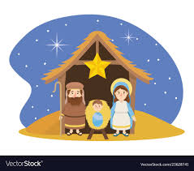
Skills I will use:
Comparing Reading Reasoning Listening Discussing Reflecting
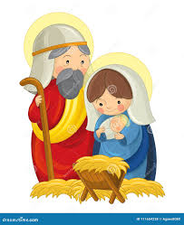

Vocabulary we will use on our learning journey:
Saviour Messiah
Christ Bethlehem Mary Joseph Jesus
shepherds angels wise men star
Mary Jones Dead Sea Scrolls
Question I would like to ask:

________________________________
________________________________
________________

