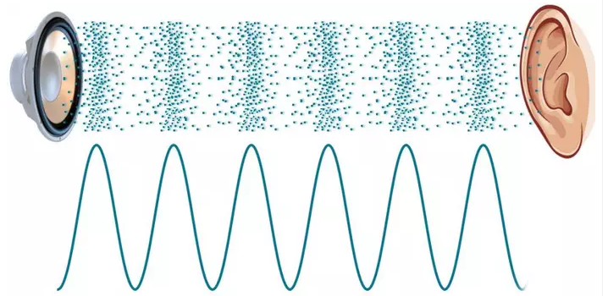

Big Picture

Why is the sound that “Taylor Swift” makes enjoyed by so many?

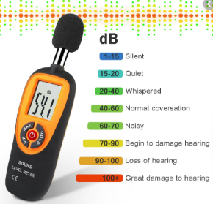





**Questions we will investigate:**

What is a sound ?

What is a sound source ?

How are sounds heard ?

Can sounds be heard through any materials ?

What is pitch ?

**Skills we will use:**

observation

drawing

recording

making

investigating

comparing

discussing

**Vocabulary we will use:**

sound source

vibrations

sound waves

air particles

volume

amplitude

pitch

materials

**Question I would like to ask:**

LO To assess prior knowleddge

**What do I already know**

**about SOUND ?**

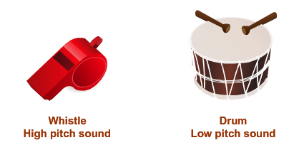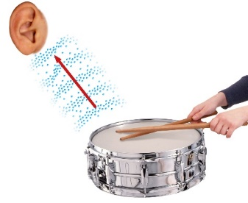

LO To assess prior knowledge

**What do I already know**

**about SOUND ?**

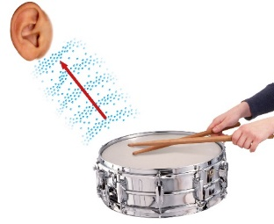



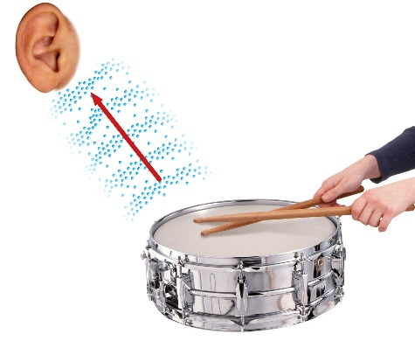

Big Ideas

Why is the sound that “Taylor Swift” makes enjoyed by so many?

**Vocabulary**

**sound source** – anything that creates a sound

**vibrations**- when something moves back and forth or shakes

**sound waves**- when vibrations travel through the air to our ears so we hear them.

**Volume** how loud / quiet a

**amplitude** sound is

**pitch -** how high or low a sound is

The sound source creates vibrations which travel through the air. Each air particle passes the sound vibrations to the air particle next to it until it enters our ear.

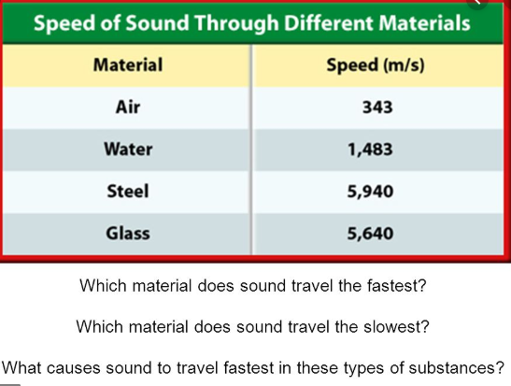

The loudest natural sound on Earth is that of an erupting volcano.

Sound waves

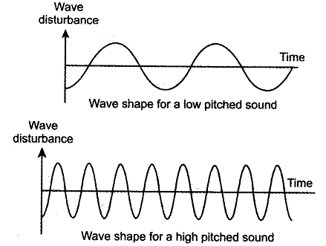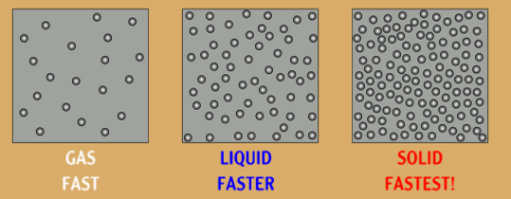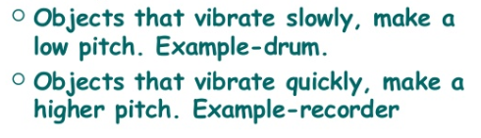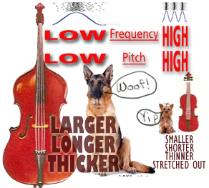

**or whistle.**