|  |  |
| --- | --- |
| **Key Words** | |
| worries | Something I am anxious about |
| hopes | Something I want to achieve or do |
| belonging | Being part of something bigger |
| rights | What I entitled to |
| responsibilities | What I should do |
| safe | To feel secure and looked after |



**BIG IDEAS**



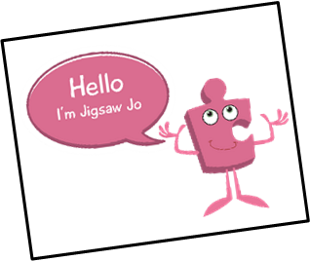 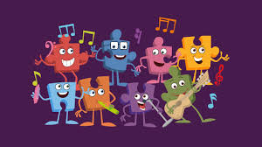

I can recognise when I feel worried and know who to ask for help.

I work cooperatively.

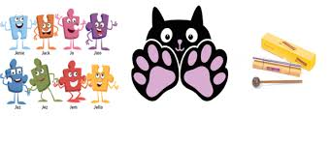

I know how to help myself and others feel like we belong.

I help to make my class a safe and fair place.

