Key Words
Change | When things don’t stay the same
Achieve | When you do something you have wanted to do
Resilience | To keep trying even when things get tough
Dream | Your own personal goal or what you would like to achieve
Proud | To be happy with something you have done or achieved
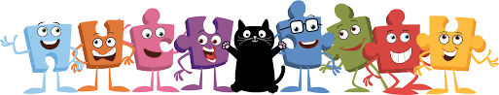
Dreams and Goals
BIG IDEAS

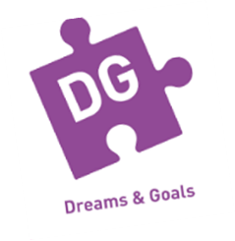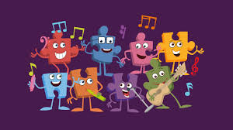
I am POSITIVE about myself and others.

I keep TRYING when things are hard or don’t go well.

I work hard to ACHIEVE my GOALS and DREAMS.
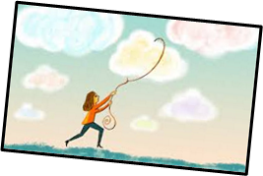
I am trying to achieve my DREAMS!

I work well with OTHER PEOPLE.
