Why was the Islamic Civilization around AD900 known as “The Golden Age”?
Questions we will explore:
- What did this ‘Golden Age’ give the world?
- Who is the Prophet Muhammad and how was he associated with the ‘Golden Age’?
- What part did the ‘Golden Age’ have in improving health care?
- What can you discover about the art and culture of the ‘Golden Age’?
- Why did the ‘Golden Age’ come to an end?
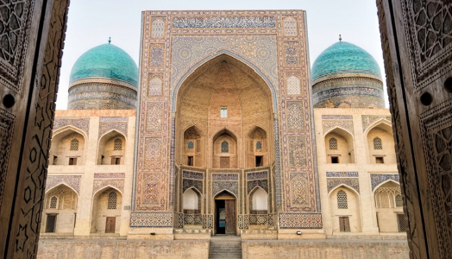
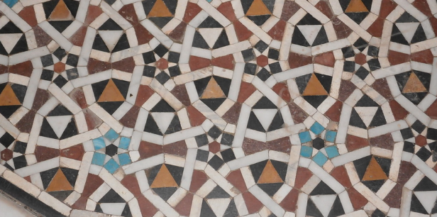
Skills we will use:
- Research including ICT
- Debate and discussion
- Reflection
- DT
- Reading and evaluating

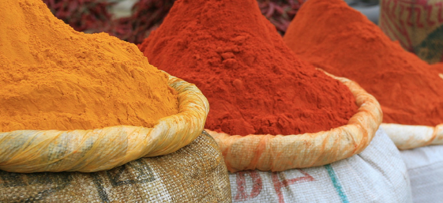
Vocabulary we will use:
Baghdad, House of Wisdom, Empire, Silk Road, Allah, geometric, calligraphy, Mecca
Questions I would like to ask?
____________________________________________________________________________________________________

