Big Picture

**How do we conserve earth’s resources?**

**Focus: Recycling**

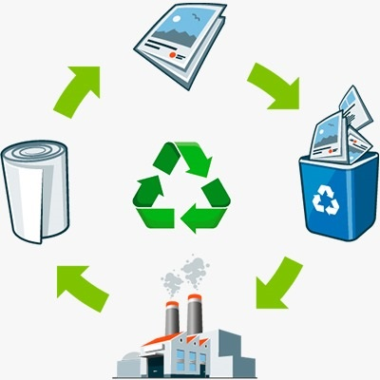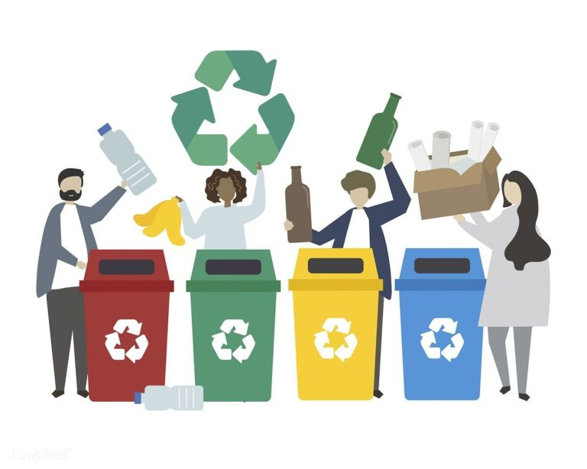

**Vocabulary I will use….**

* Reduce, reuse and recycle
* Natural and manmade resources
* Renewable and non-renewable
* Environment
* Pollution
* Conserve

**Skills I will use….**

* Research
* Observation
* Discussion
* Reflection and evaluation
* Experiment and investigate
* Design and creation
* Hypothesise and predict

**Questions we will explore:**

* Why is it important to recycle?
* Can we identify and sort recyclable materials?
* What happens at a recycling plant?
* Can we suggest ways we can reduce, reuse and recycle and inspire others to do the same?

**Questions I would like to ask…**