Big Ideas- Which characters will I meet in traditional tales?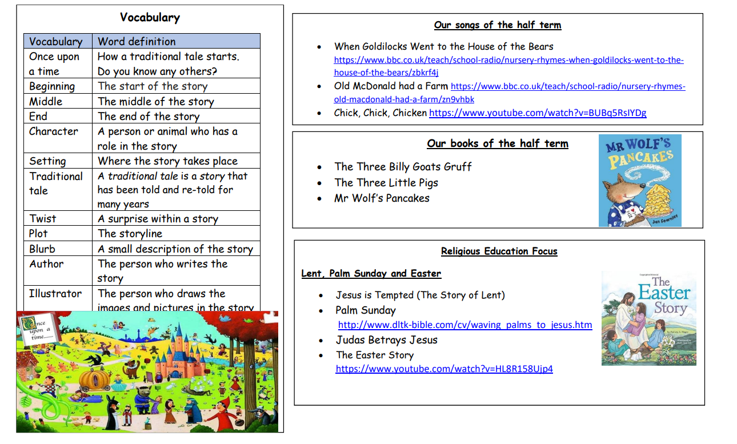

Big Picture
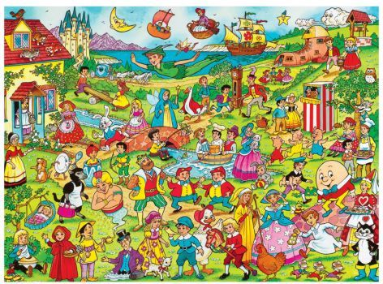
Which characters will I meet in traditional tales?
Skills I will use:
- Observing
- Exploring
- Learning
- Drawing
- Sharing
- Discussing
- Imagining

Questions We Will Explore
- What is a traditional tale?
- What characters will we meet?
- Are they all made up stories?
What I want to know?
- Why there are so many stories about animals?
- Why is goldilocks badly behaved?
- Why are there lots of foods in the stories?

