Why are some places in the world always hot and some always cold?

- How can you use maps and a globe to locate the Equator, the North Pole and the South Pole?
- How have people adapted to live in a very hot climate?
- How have people adapted to live in a very cold climate?
- Which animals will we find living naturally in very hot or very cold regions?
Big picture

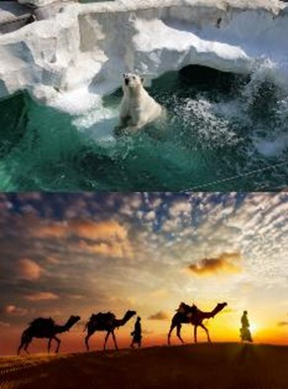
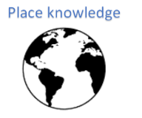
Skills we will use:
map skills comparing
date collecting
reading maps identifying
discussing questioning

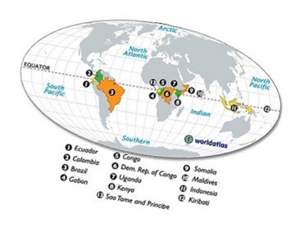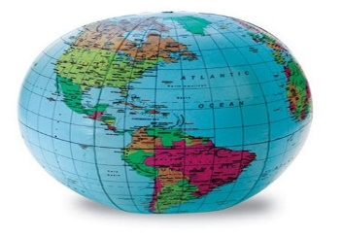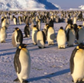
Question I would like to ask:
Vocabulary we will use:
North Pole Equator
South Pole camouflage
desert glacier

