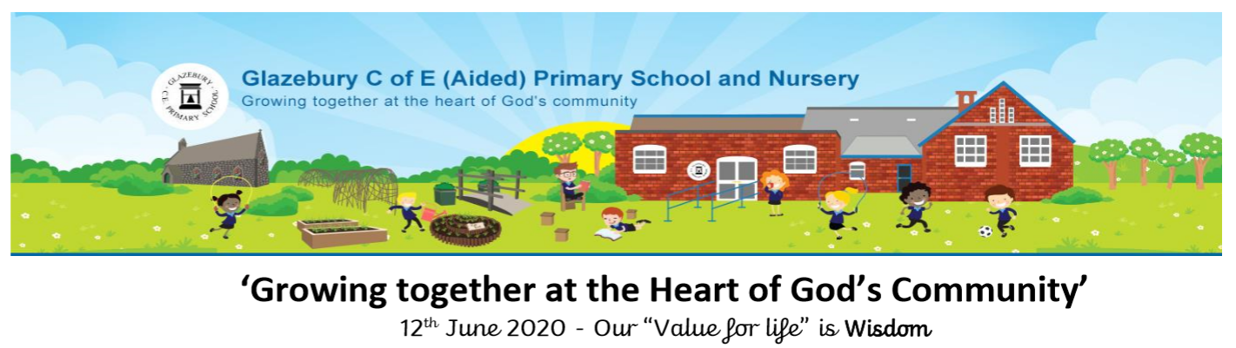

Year 6 Newsletter

Dear Parents/carers: Just to confirm that for those that have confirmed a place to start on Monday 22nd June 2020, our family bubble starts at 8.45am and ends at 12.15pm. We are really looking forward to seeing you on Monday 22nd June 2020.

For those pupils who are still at home, you will receive a new home learning pack on Fri 19th June and a phone call to catch up every week. Please be assured we have not forgotten our home learners and you are constantly in our thoughts.

Keep looking out for more information about future events….

Work we are proud of:

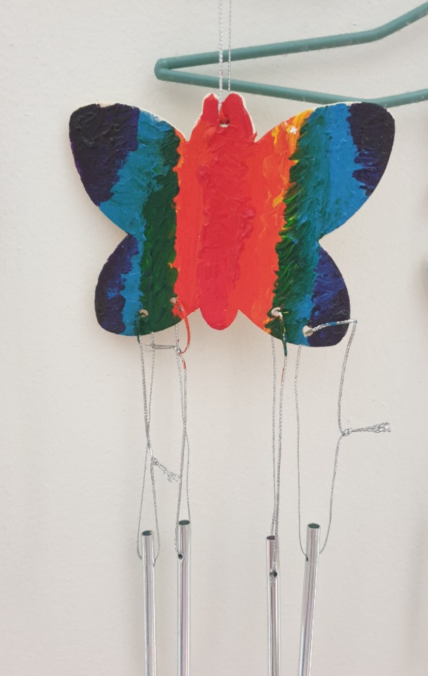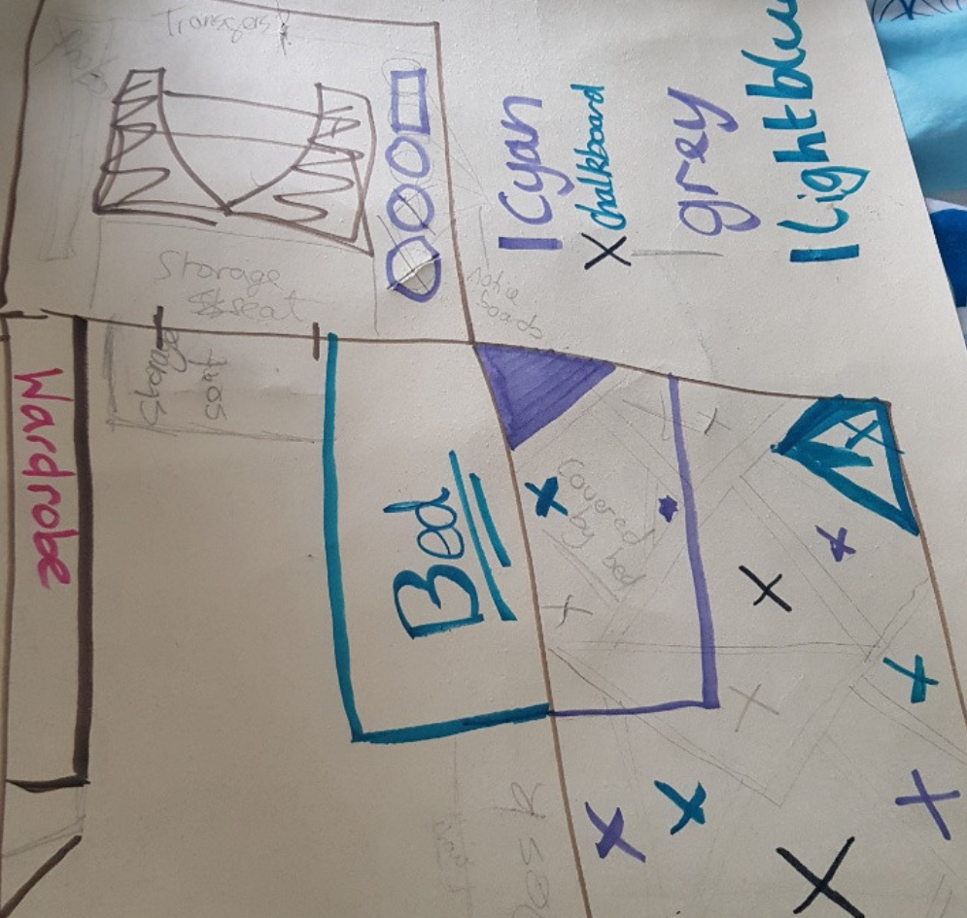

Gabriella Eva

Please keep sending us photos of your work to celebrate via Dojo.

Video challenge:

We would like to produce a video for our lovely year 6s which we can edit together as a memory for you all. Task:

Film yourself catching a Glazebury jumper from your right, opening it out to show the camera and then throwing it of screen to your left. You can be as inventive as your wish with the location and direction of the clip but please keep it under 15 seconds.

E-mail the clip to glazeburyprimary@ldst.org.uk

Mr Snelson has offered to edit it together for us and we will share it out with you.

Message board:

Please send messages for your fellow Year 6s via Dojo and we will place them here.

Message from Mr Snelson:

‘Rivers know this: there is no hurry. We shall get there some day.’ Winnie the Pooh