How does light help us see?
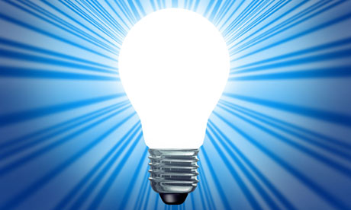
Skills I will use:
- Observation
- Research
- Reflection and evaluation
- Art
- DT- use of tools
- Fair Test/Experiments.
Questions we will explore;
- How do we know that light travels faster than sound?
- How can I conduct a fair experiment to show light travels in straight lines?
- How do your eyes work?
- How does a periscope work?
- What is the impact when you are blindfolded?
- How are shadows created and how can they be altered?
- Can you use water colours to create a landscape or still life painting which shows light and shadow?

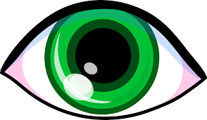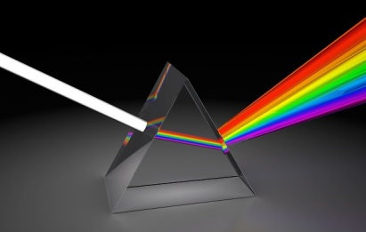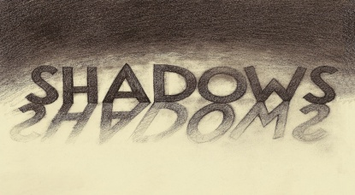

Vocabulary we will use;

shadow, filter, colour, reflect, absorb, refract, spectrum, wavelength, prism, visible, lens, angle, incidence, ray, beam, photon, source, opaque, distance, tilt, transparent, bend, focal point, periscope, travel, vacuum,

Questions I would like to ask?

