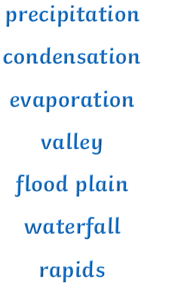

**Question I would like to ask:**

**Geographical skills we will use**

**Asking geographical questions.**

**Collecting, analysing and interpreting data**.

**Interpretating a range of sources** of geographical information, including maps, diagrams, globes, aerial photographs

**Presenting geographical information** in a variety of ways, including through constructing maps, drawings, diagrams ,charts and graphs, and writing.

Critically **evaluating** and debate the impact of geographical processes.

**Vocabulary we will use :**

**meander**

**tributary**

**flow**

**source**

**mouth**

**erosion**

**deposition**

**How are rivers formed ?**

**What are the features of the upper, middle and lower courses of a river ?**

**Why have so many cities been created near a river ?**

BIG PICTURE

**Where do rivers begin and end ?**