**Celebrating the Eucharist...Why?**

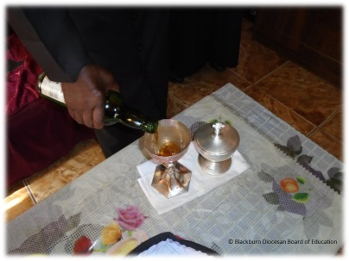

**Questions I would like to explore?**

*I can explain why Christians celebrate the Eucharist?

*I can say who takes part in the Eucharist?

* I know why the Eucharist has several names?

* I have explored how the Eucharist is worded?

* I can say what the Passover and the last supper are?

[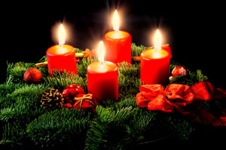](http://www.google.co.uk/url?sa=i&rct=j&q=&esrc=s&source=images&cd=&cad=rja&uact=8&ved=0CAcQjRxqFQoTCJSjlcDhgckCFYNrFAodVPwNnA&url=http://antonian.tv/category/kulture/page/14/&bvm=bv.106923889,d.ZWU&psig=AFQjCNGb-jB0Mo6VkkIJkumYKCzqaymFGw&ust=1447104080938232)

*Vocabulary we will use:*

Eucharist, Holy Communion, Last Supper, remembrance, holy, sacrifice, mercy, salvation, sacrament and faith

*Values:*

* Faith
* Forgiveness

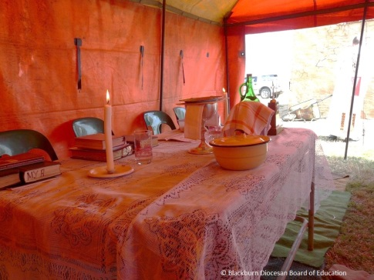 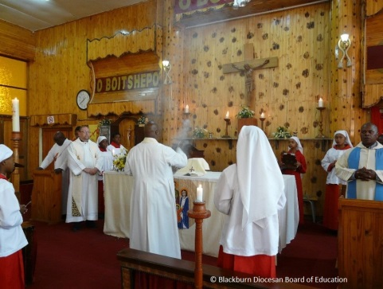

Skills I will use:

* Investigate
* Apply
* Enquire
* Synthesise
* Analyse

Questions I would like to ask...