Were the Vikings always victorious and vicious?

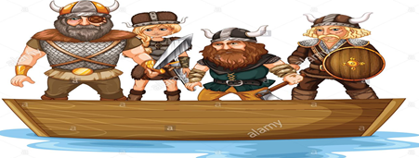

Questions we will explore;
- Who were the Anglo-Saxons and did they like the Vikings?
- Why did the Vikings come to Britain and how did they make the journey?
- What did the Brits learn from the Vikings?
- What was life like for a 11 year old (boy/ girl) Viking?
- How did the Vikings live when they came to Britain?
- How can you create a Viking long boat from a range of materials?
- What did the Vikings eat and could you recreate a Viking meal?
Skills we will use:

Research including ICT
Debate and discussion
Reflection
DT- use of tools
Reading and evaluating
Atlas work

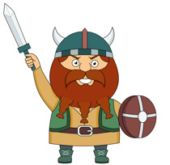
Vocabulary we will use:
Timeline, chronological, civilizations, invasions, ancient, legacy, trade, Heptarchy, journey, Viking longboat, raids,
Questions I would like to ask?

