Could you be the next CSI investigator?
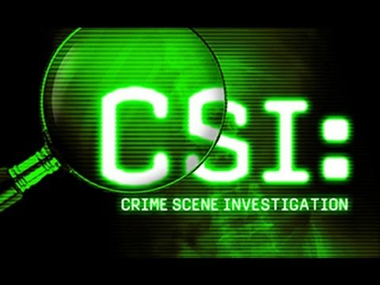
Questions we will explore:
*Can you think of five materials that can be changed and reversed and five cannot?
*How have scientists made use of changes to create materials that make our lives easier?
*Which materials dissolve and evaporate and why can this sometimes be an important quality in those materials?
*How are reversible and irreversible changes important to forensic scientist?
*What is bicarbonate of soda and what impact does it have on different materials?
*Using finger prints as well as hand and foot prints, can you create an interesting piece of art work that has interesting design features?
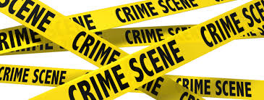

Vocabulary we will use:
Properties
Changes
Materials
Reversible
Irreversible
Solubility
Transparency
Conductivity
Magnetism
Substance
Filtering
Sieving
Solid
Liquid
Gases
Forensics

Questions I would like to ask...

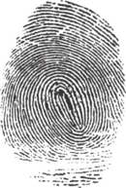
Skills I will use:
- Observation
- Research
- Reflection and evaluation
- Use of IT.
- Art
- Presentation via powerpoint
- Fair Test/Experiments.

