Key vocabulary | Definition
Absorb | Absorb means to take in or soak up. The absorption of light occurs when a ray of light strikes a surface. The energy from the light is transferred to the surface material.
Block | An obstacle to a function.
Darkness | The partial or total absence of light.
Mirror | A surface, typically of glass coated with a metal amalgam, which reflects a clear image.
Opaque | Not able to be seen through; not transparent.
Translucent | Allowing some light, but not detailed shapes, to pass through; semi-transparent.
Transparent | Allowing light to pass through so that objects behind can be distinctly seen
Big Ideas- Light
Light sources:
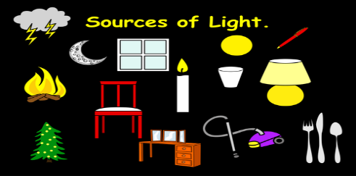
Sources of light are things or devices that produce light, and the two general sources are natural and artificial. The sun is Earth’s main source of natural light.
Reflective
When light from an object is reflected by a surface, it changes direction. It bounces off the surface at the same angle as it hits it.
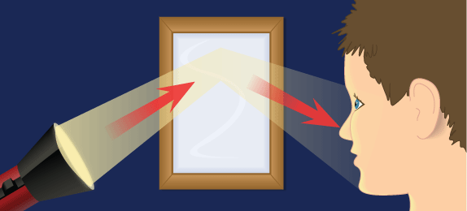
Shadow
Shadows are formed when the light from a light source is blocked by a solid object
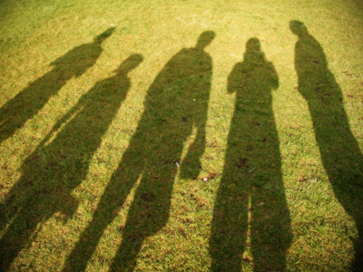
How the eye works:
