Returning to School
Social Story

On ……………….. I will be returning to school. This may make me feel worried. It is ok to feel worried, but it is also ok to feel happy and excited.
Insert own school photo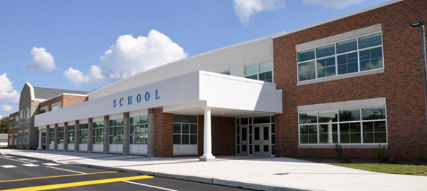

School will feel different for a while. To help keep everyone healthy, some adults and children will not be coming into school. I will still come into school.

When I am in school, I will need to wash my hands a lot so that I can stay healthy.

Another thing I will have to do to stay safe and healthy is called social distancing. Social distancing means I cannot be close to other people.
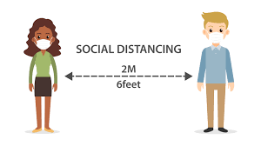

My classroom and areas around school will look different.
Insert picture of classroom/ areas of school e.g. dinner hall

All the adults in school are there to look after me and help me if I feel worried. If I feel this way I can talk to …………….. that will help me feel better.

When everyone is healthy again, all the other adults and children will return to school and we will be able to continue our learning together.

