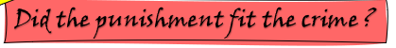
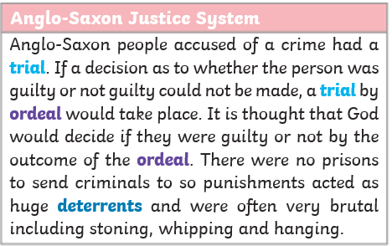
Romans’ Rule
Roman laws, written around 450 BC, were called the ‘Twelve Tables’. Not following these rules was a crime. Punishments were severe to deter people from not following them.
Legionaries in Britain would be responsible for finding and catching suspects, Judges and juries were used to decide if someone was guilty or not guilty. People could pay to have their punishment lessened. The worst crime, treason, had the harshest punishment.
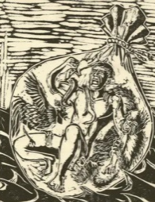
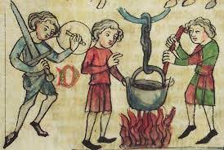
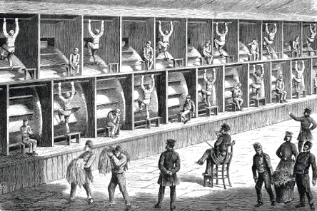
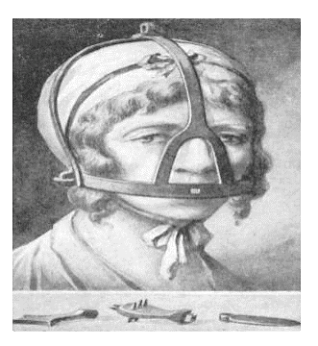
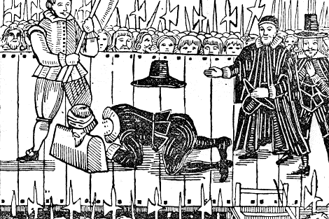
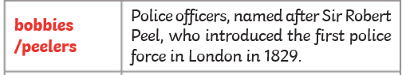
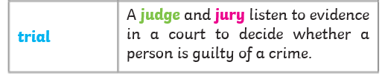
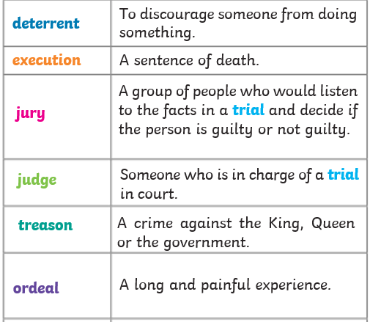
The Tudors
wergild
means 'blood price', was a system of fines used by the Anglo-Saxons, where, if you injured someone, the victim received money
The Victorians looked for alternative ways to hanging people for committing crimes. Many prisons were built in order to prevent people committing further crimes. Life in prison was very tough. Prisoners had to do very physically demanding tasks. These included:
- the treadwheel - using the steps on a huge wooden and iron wheel to move it
- shot drill - lifting a heavy iron cannonball
- the crank – machinery that victims turned 10,000 times a day

Victorians Villains
Tudor Torture
To deter people from committing crimes, the Tudors came up with even more terrifying punishments, including public executions. Public humiliations were common. The scold’s bridle was worn for gossiping; the rack used to stretch out the victim’s body for treason; and the dunking stool to find out if someone was a witch.
Key vocabulary
The Victorians
The Romans
The Anglo- Saxons
43 450 1066 1485 1603 1837 1901

