Big Ideas
ARE ALL CHURCHES THE SAME ?
vocabulary | meaning
chapel | a small building or room used for Christian worship in a school, prison, hospital, or large private house.
cathedral | A cathedral is a large Christian church.It is the main church of a bishop's district.
sacrament | The sacraments are rituals that teach, strengthen and express faith. They are relevant to all areas and stages of life eg baptism, Eucharist
denomination | - Denominations mean different groups within one main group.  - That means there are many different types of Christian but they all belong to the main group called Christianity.  - All Christians:  - Believe in one God  - Follow the teachings of Jesus  - Their holy book is called a Bible.
synagogue | A building where Jewish people worship
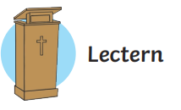
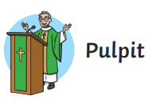
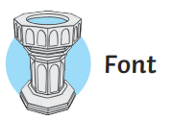
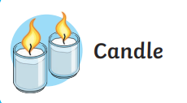
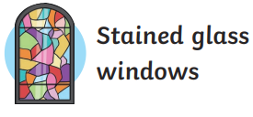
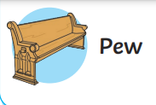
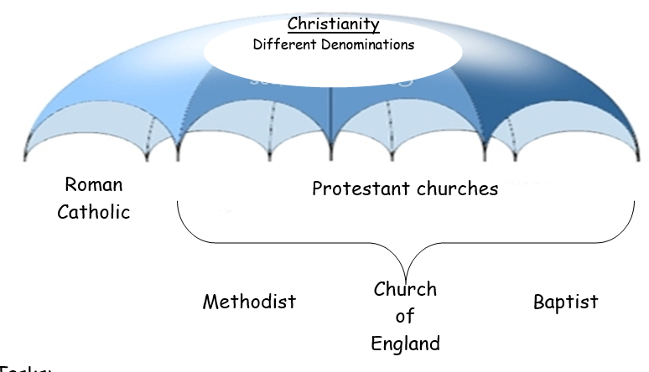
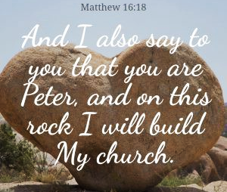
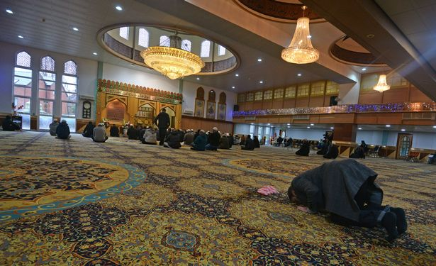
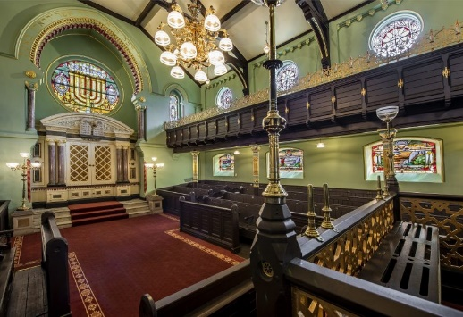
The word church refers to a physical building, but more importantly, to the people whom God calls and gathers together.
These items will be found in most Christian churches.
They may be modern, old, larger, small and made of different materials.
Muslims attend a mosque
Who was Peter ?
Saint Peter, also known as Peter the Apostle, Peter the Rock, Simon Peter, Simeon, Simon or Cephas, was one of the Twelve Apostles of Jesus Christ, and one of the first leaders of the early Church

Jewish synagogue

