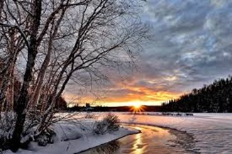

Big Picture

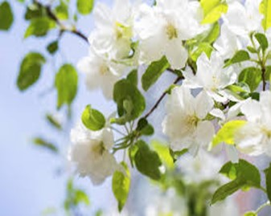

**Autumn 1**

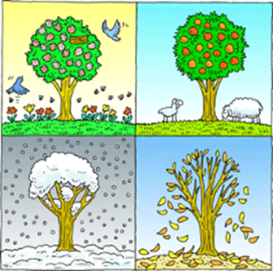

**What is seasonal change?**

**Vocabulary we will use…**

**autumn, winter, summer, spring, temperature, weather symbols**

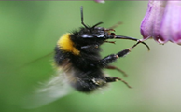

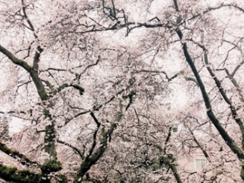

Question I would like to ask:

______________________________________________­­­__

**What will we explore in this unit?**

* Why do we have seasons and what are the months associated with each?
* Why do most people love the spring?
* What do we know about summer?
* Why are there so many leaves on the floor in autumn?

**Skills we will use to know that we can ask questions about the world and that when we observe the world to answer these questions, this is SCIENCE!**

**Talk partners, research, grouping and classifying, observing, drawing, discussing, writing.**